IDEA Project “Innovative Development of European Areas by Fostering transnational Knowledge Development“ (Project No. 2CE175P1)

Work Package 6
Final Report

Work package 6.4
IDEA strategy – Final report on Innovative Development for European Areas by fostering transnational Knowledge Development

Prepared by:
Sylke Spröd, Ronny Donath, Martina Ganß, Ralica Ivanova, Helena Cvenkel, Robert Leskovar, Nataša Urbancíková, Oto Hudec, Gabriela Kolvekova, Ákos Szépvölgyi, György Fekete, Marco Novarese, Serena Novero, Sara Gervasi, Anna Kaminska, Aneta Węglińska, Malgorzata Iwona Szynkowska, Iva Cernanská, Bořecký Karel, Christina Färber, Alexandra Pawelek
Contents
Es wurden keine Einträge für das Inhaltsverzeichnis gefunden.

Abstract
In knowledge-based economies of Central Europe economic growth largely depends upon the pace and the quality of the innovation process. Regional economic development in Europe is increasingly limited by its quantitative and qualitative potential in human resources. The competition between regions in Europe has become to a large extend also a “demographic race” for well trained employees where regions in Central Europe have predominately experienced a brain-drain. Europe’s social and economic cohesion in the future in terms of knowledge development requires new joint transnational approaches.
The target of IDEA project is the development of an adequate strategy which will enhance small and medium sized enterprises in the regions of Central Europe to face the increasing demand of innovative and highly qualified workers (High Potentials) with tested methods and instruments. Realised by establishing and improving transnational cooperation this strategy is exemplary for participating regions and actual transferable for Central Europe. Regional activities will be analysed and evaluated using a bottom-up approach. Existing suitable approaches will be disseminated and enhanced in pilot actions, where new ideas will be generated, examined and implemented simultaneous with project duration. The IDEA Strategy will consist of following key parts: 1st description of current situation and framing conditions, 2nd distinguishing of the scope of the strategy, 3rd sub strategies derived from the pilot actions, 4th methodologies, instruments and tools for implementing of strategic activities.

Goals and methods of the project
An increasing interest has emerged both in theory and policy, which focuses on the importance of knowledge, learning and innovation to the economic success of firms, regions and nation-states (Lundvall, 1988; Forrant, 2001). New theories emphasize the role of human and social capital in regional growth and development as missing elements of its explanation. Regional strategic planning and decision-making suppose high quality of human capital and the involvement of regional authorities, research entities and business community in national and European initiatives to mobilize and to facilitate actions.
Innovation takes a central role in the process of economic development, when defining it as a product, process and organizational innovation in the firm as well as social and institutional innovation at the level of industry, region or nation. Since economic development can be understood as a process of innovation activities, innovation emerges as the engine of growth and the role of institutions is an essential variable, “the national innovation system became an important part of national industrial policies” (Lundvall). As the conditions of regions in the regionalization process are gradually changing over the time, what brings – in accordance with learning regions concept - new challenges such as change of the regional governance system toward more networking structure, embedding together cooperation and competition, away from hierarchical structures. Regionalization accompanied by decentralization of power and resources leads to a situation when regional (innovation) policies started to play more important role.

Regional innovation systems
An important input for the discussion comes from the regional innovation systems (RIS) approach, which accentuates the critical significance of geographical proximity and adequate institutional support of economy, entrepreneurship and innovation at the regional level. The concept of the regional innovation system appeared in the early 1990s, integrating two ideas: the systematic nature of innovation activity and the regional dimension of the innovation process. Its systematic approach is based on the specific nature of innovation activity, which results from cooperation among business entities based on mutual trust in creating, disseminating and applying new knowledge.
A strong, regional innovation system is one with systematic linkages between external as well as internal sources of knowledge production (universities, research institutions and other intermediary organizations providing innovative services) and firms (both large and small). Most regions do not have these systemic innovation characteristics.
The role of main actors in innovation process varies and includes:
- Universities and research institutes; which educate specialized R&D manpower and lead to the process of new knowledge creation through collaborating with research institutes
- Firms; mostly focus on creating new knowledge that enable them to commercialize, while executive officers (CEO-s) are keen to learn whether or not new technology can create market demand
- Government; legal system regarding R&D heavily influences CEO-s and the preconditions for R&D activities. Therefore policy makers in a national government have to supply human and natural resources for optimum R&D activities, local government must create ideal business environment to provide various incentives and supports for new start-ups in regions and improve living standards in local areas (VINNOVA 2001).
- Human Capital and High Potentials; create inventions and can transfer these into real innovations (within the context of the institution they work for or by becoming entrepreneurs and starting businesses with innovative ideas).

Definition of high potentials
The bigger companies of all sizes and industries are managing gradually more diverse workforces across a complex cultures, geographies, and economic environments. Human resources departments and organisations are challenged to identify, assess, develop, and retain high-performing and high-potential talents.
High potentials consistently and significantly outperform their peer groups in a variety of settings and circumstances. While achieving these superior levels of performance, they exhibit behaviours that reflect their companies’ culture and values in an exemplary manner. Moreover they show a strong capacity to grow and succeed throughout their careers within an organisation - more quickly and effectively that their peer group do. Additionally, we defined high potentials talents as an employee who is assessed as having the ability, organisational commitment and motivation to rise to and success in more senior positions in the organisation.
The role of high potentials in regional growth and development is highly connected to regional innovation systems and vice versa, which were first mentioned in 1990's in the regions/or states and their key substances.
We may suppose that the assets in the innovation-based economic development model include human, intellectual, financial, physical, and institutional capital located in a region. Talented people construct new ideas driving innovation and regions are increasingly advertising strengths in skilled labour to attract and preserve innovative companies. Many studies of business location decisions have shown skilled labour to be such an important asset, that a lot of regions have made it the central topic of their regional marketing efforts. Indeed, the presence of high potentials is a basis for business attraction. Regional administration is not able to develop a skilled workforce without investment into the institutions that generate and cultivate talents such as universities and other educational and training institutions.
If a region is attractive for high potentials - highly skilled and talented human capital, the regional innovation activity becomes more dynamic leading to its economic growth and competitiveness increase, attracting in turn new highly skilled labour force. This means, a circle exists – the low proportion of highly skilled labour force makes the region less competitive. The less competitive region is not attractive for highly skilled labour force. When explaining innovation performance, human capital (read high potentials, inventors, etc.) is a key asset.
Networks among mentioned actors and establishing close cooperation with one another are solid bases to create technology innovation. Interactions between the actors in regional innovation system have been insufficiently explored, while the institutional context of these interactions has been to a large extent overlooked. As a result, the validity of the recommendations for innovation policy making based on the current analyses of regional innovation systems is somewhat questionable. Since regional innovation policies most of policy measures are focused on improving innovative capacity of SME-s (focal recipients of R&D support), this "indicates that SMEs are the core factor for a regional innovation system (Simon, 1996), while Schumpeter already in 1931 urged that" a driving force of economic growth is based on entrepreneurship. The innovation system itself is not regarded as productive unless it creates new products in the domestic and global markets. Therefore a commercialisation process is very significant in order to link the innovation system to economic growth.
High potentials are intensively studied in the regional science and/or "new economic geography (Krugman, 1991, Nobel prize winner in 2008). Economic geography includes characteristic patterns of successful regions; the existence of a strong SME sector, intensive horizontal work structure, a dense infrastructure of supportive institutions and organisations, innovative regional culture and an active regional government (Zeitlin (1992), Pyke and Sengenberger (1992).
Regional development is essentially based on human capital assets, as a necessary precondition. Small and medium enterprises are in a less favoured situation, fighting for good quality graduates with large companies. As one of the key measures to strengthen the high potentials the acquisition training in SMEs is promoting and assisting the SMEs in their innovation, research and development activities via creation of well-functioning, regional and SME tailored innovation system.

Description of current situation in the regions
The project is implemented by the consortium of experienced and competent partners from all eight central European countries. Coordinating partner is ICM - Institute Chemnitz. The partners have experience in promoting innovation within their respective area of responsibility and their regions. It was recognized that especially the technological aspect of innovation development is the most important point. The increasing mobility of people intensified the demographic change in Europe. The role of human capital in the competition between regions is increasing. The pressure of innovation within the regions is increasing too. So it is necessary to explore new cooperative ways of qualitative and quantitative protection of human capital.
The different experiences from the regions therefore present a significant enrichment of the project. The experience of the project is very important for the general partner's knowledge in the innovation process as well for stakeholders and decision makers who are involved to strengthen the transnational relations and connect the regions close to each other. The following chapters will give a short introduction to the regions, their starting conditions and challenges regarding future technologies, human resource development as well as cooperation and networks.

The participating regions and their characteristics
Within a benchmark study the eight European regions and cities have been compared regarding different aspects, such as population, economic strength, and attractiveness of locations in terms of living conditions. First of all a short overview will follow, in order to inform about the main characteristics.
NUTS 0 | NUTS II | NUTS III
Czech Republic | Severozápad | Ustecky
Germany | Chemnitz | Chemnitz
Italy | Piemonte | Alessandria
Hungary | Közép-Dunántúl | Fejer
Austria | Styria | Upper Styria (East)
Poland | Lódzkie | Lodz
Slovenia | Zahodna Slovenija | Gorenjska
Slovakia | Východné Slovensko | Kosicky Kraj
Table 1: NUTS levels of examined regions

Germany –Region Chemnitz
Chemnitz is a modern large city at the heart of Europe - very close to the new EU members, the Czech Republic and Poland. Almost 250,000 people live in the city formerly called Karl-Marx-Stadt and the figure rises to 1.6 million in the Chemnitz administrative region.
Chemnitz is the centre of the Eastern German engineering sector. More than 100 small and medium-sized companies in the city and 500 in the local region are successfully continuing this 150-year-old tradition. The spectrum ranges from tool-making and special engineering companies to automation and vehicle manufacturing.
Most of the enterprises are acting in a niche of their branch and are dealing with deeply specialised knowledge and professions. There is a lack of specialists and experts of the so called MINT subjects (mathematics, informatics, natural sciences and techniques). In 2009 there was a lack in graduates of High schools and technical colleges. This refers to the increasing branches in Saxony as there are Mechanical Engineering, Manufacturing of motor vehicles, trailers and semi-trailers, Manufacturing of electrical equipment and Manufacturing of textiles. But also brain drain to other neighbouring cities or to Western Germany as well as the high amount of elderly people in cause of demographic change are jeopardizing the positive regional development in the future.

Slovenia – Region Gorenjska
Region Gorenskaja is an Alpine region with a characteristic diverse mountainous landscape. Seventy percent of the region is a mountainous world, while only 29.8% lies in the depressed/lowland part of central Slovenia. As much as 40.2% of Gorenjska lies more than 1,000 metres above sea level, 59.4% is covered with forests, 30.6% is agricultural land and 10% infertile land. Additionally, 44.4 % of the surface area is incorporated into NATURA 2000 sites.
Employment rate for the 15-64 age group (per gender), unemployment rate (per gender), employment rate change in the last 20 years (per gender), share of employees per economic macro-sector, usual weekly hours of work in main job, national rank of unemployment rate (position of the NUTS III region).

Slovakia – Region Eastern Slovakia
Foremost the Eastern Slovakia consists of two smaller and historically known parts, which have names Košice and Prešov region. Košice and Prešov Region are socio-economically the least developed areas of the Slovak Republic. The situation is resulting from a difficult transformation process, its peripheral location (relative to the capital of Slovakia and the EU-15) and a rather underdeveloped transport, technical and civil infrastructure.
The regions in eastern Slovakia are facing similar problems - especially low competitiveness, high unemployment, infrastructure and capital deficiency. On the other hand, eastern regions have, in addition to geographical proximity, strong potential for more and coordinated economic and social links, in particular more efficient use of its assets (geographic, natural, human resources, economic and social clusters, etc.). The greater Košice city region is much developed than the surrounding rural areas. The unequal demography of people entering the labour market in year 2010 (i.e. people born about 20 years ago) is one of the factors influencing the supply of high potentials. But in twenty years from now the labour market may face the lack of high potentials due to smaller pace of increase of population. On the other hand migration reveals a potential for finding high potentials emigrating to Slovak Republic.

Hungary – Region Central-Transdanubia
Central-Transdanubia (CTD) has a good geographical location as well as geopolitical position. CTD has 1.1 million inhabitants, 15,6% of the total labour force have tertiary education, 14,3% of total employment is in high and medium-high technology manufacturing and 20,6% of total employment is working in the knowledge intensive services. The unemployment rate is about 8% with 56% activity rate.
Nowadays, the Region has no specific economic orientation. Despite, there are some economic branches which potentially may be regarded as the region’s present and future key industrial sectors. They are as follows: mechatronics, car industry, material science related technologies, environmental industry and technologies (especially renewable energies), IT industry and food industry. These sectors are mainly connected to foreign owned multinational companies and have huge economic potential with limited regional added value and R&D potential. The region’s limited higher educational and public funded research-development capacities raise serious problems for enterprises as well. The economics-oriented higher education system fails to meet the demands of enterprises of mostly technical nature. This results in occasional and weak cooperation among the higher educational, R&D and business sectors.

Italy – Region Piedmont
Alessandria is a city in the Piedmont Region of 94.191 inhabitants, the third city as regards population after Turin and Novara; it is the capital of Alessandria province. Structural feature of population of Alessandria province is the low percentage of young people and the high percentage of elderly persons.
The main industry centres are all around Alessandria, in the provincial territory. Industry system of Alessandria province progressively assumed connotations more and more specialized in the different sectors of engineering industry (more than 44% of the workers if you consider also Valenza jewellery), chemical and plastic sector (11,7%) and food sector (7,6%). There are many artisan enterprises in the sectors of manufacturing, building and transports. It’s very important also trade sector both as regards traditional shops and large scale distribution.

Poland – Region of Lodz
Łódź is the third-largest city in Poland. Located in the central part of the country, it has a population of 742,387 (December 2009). The city benefits from its central location in Poland. A number of firms have located their logistics centres in the vicinity. Two planned motorways, A1 spanning from the north to the south of Poland, and A2 going from the east to the west will intersect northeast of the city.
Until recently it has been one of the largest light industry centres in Europe, and today constitutes a centre for modern branches of industry, including IT, household goods manufacturing and the business services sector headed by BPO. The basis for development of the 21st century city is a long-term strategy developed by the McKinsey's consultants. In Łódź high educational and scientific potential is concentrated. There are 23 schools which have the status of universities, 30 R&D institutes and centers. Over 127 000 students are studying at the university level. Every year there are over 24 000 universities graduates.

Czech Republic – Region Ustecky
The Usti region has a centuries-old tradition of industrial and agricultural production, business activities and rich networks of traffic routes. Region faces the highest unemployment. Rate – 13, 61 % in 2009, the unfavorable educational structure, dependence of economy in several sectors (coal mining, energetic industry, chemical industry, mechanical engineering), a low level of regional research and development.
The Usti region is extremely rich in natural beauties, like mountain areas and mineral or hot springs. There are a lot of beautiful historic sites, castells and mansions throughout region territory. There are also many opportunities for sport-oriented visitors – for example the Autodrom Most Race Circuit, or the hippodrome in Most.

Austria – Region Styria
Today the region, where material has always been the core, has a phenomenal amount of know-how, competence and future prospects. Over centuries Styria has developed into one of the most competent material regions throughout Europe. Material competence is the decisive competitive edge for innovative high-performance products of the future. This is the reason that highly qualified experts and specialized staff along with outstanding service providers have a preference for the application range of their knowledge: the high-tech enterprises of Styria.
Being perfectly positioned near major roadways; having easy access to institutes of higher learning that are economically oriented like the University of Applied Sciences in Kapfenberg or the Montan University in Leoben and benefiting from synergies in intact surroundings.

Benchmarking of the regions
The data has been collected on the statistical level NUTS III, and for some indicators also on NUTS II, depending on the availability. Table 1 shows regions and relating statistical levels, which will be examined in this benchmark test. The selection of indicators for the ranking is based on migration theories. According to Lee, there are two factors – push and pull – influencing decisions on moving in or out a specific region. Sjaastad defines such individual decisions as a cost-benefit equation. In that context a region needs to be considered in a double sense. On the one hand a region can be a target region, i.e. recruiting professionals, who will be living in that region, on the other hand a region can be the origin, where professionals are educated and will stay in that region. Further criteria for the selection of relevant indicators are the availability of data as well as their comparability between the examined regions. Other surveys comparing cities or regions will also be considered for that purpose.
The benchmarking of the regions has been conducted within the following topics:
• Demography
• Economy and Employment
• Creation and Recruiting of ProfessionalsFuture technology fields of innovation and future jobs
The overall number of three indices for indicators of the subject areas ‘Demography’, ‘Economy and employment’ and ‘Creation and recruiting of professionals’ are shown in table 1. The total of values of all indicators will be divided by the number of included single indicators, which results in an average value of min. one to max. eight, indicating the overall position of the examined region. A high value describes a region being well-positioned regarding the particular indicators.
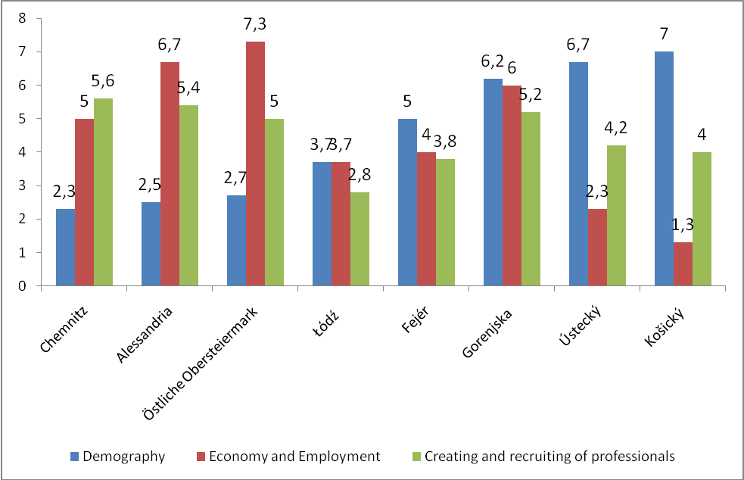
Figure 1: Regional ranking by three indices
Figure 15 presents the summarized scores for each subject area of the different regions and cities. Kosicky achieves the most favorable score for ‘Demography’, closely followed by Ústecký and Gorenjska. The most disadvantageous scores can be found for Upper Styria (East), Alessandria and Chemnitz. For ‘Economy and Employment’ Upper Styria (East) reaches best scores. With a clear distance Kosicky shows the most disadvantageous scores in this area. Chemnitz is scoring best in the area ‘Creation and Recruiting of Professionals”, while Lodz is scoring worst. However, the distances in that area are not very large.
In addition to regarding indicators at the present moment, specific indicators were examined from a dynamic perspective (see table 1). Independently of the score, we can make statements in terms of the regional development. We have applied the following methodology: comparing the respectively most current value with a 2001 value (in some cases also 2002 value or latest available value). In case of a positive development a region can reach a score up to 8. Analogous to the ranking of the static indicators the second best region reaches a score of seven, while regions with the most disadvantageous development attain a score of one. All indicator scores are then added up and divided by the number of included indicators, which results in a value range from one to eight.
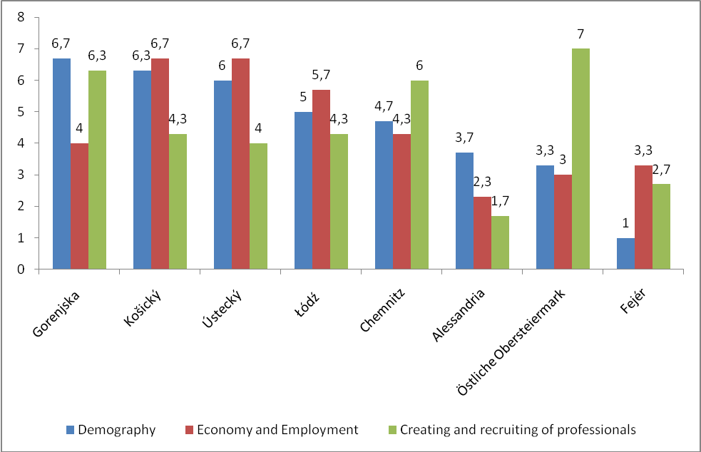
Figure 2: Regional ranking by three indices with dynamic perspective
Looking at the demographical development, Gorenjska shows the most positive development. Only slight improvements can be achieved by Fejer. In the area ‘Economy and Employment’ we find Kosicky having made the most significant improvements, closely followed by Gorenjska and Ustecky. In comparison to the other benchmark regions Alessandria shows the poorest development in that area. With regards to the ‘Creation and Recruiting of Professionals’ Chemnitz and Upper Styria (East) have had the most positive development with a clear distance to the other regions and cities.
As the analysis has shown the different characterstics of the regions on a regional level the following chapters will look closer on problems and challenges on a transnational perspective.

Demands of labour market
The main impact of demographic change and brain drain is the difficulty for employers to find suitable employees taking over the position and tasks of retired experienced workers or professionals. On the one hand a shortage of young people in cause of overaged society may be intensified by brain drain of the young talents to other attractive cities. On the other hand the specalisation of products and processes of the firms can lead to demands for qualifications and competences which are difficult to find at the labour market. The gap between supply and demand at the labour market can have different sources and has been referenced in various studies according to Tarique & Schuler:
“Studies in this category have found that a majority of employers worldwide are having difficulty filling positions due to the lack of suitable talent available in their markets (Strack et al., 2008). Several studies have attempted to describe the shortages in emerging economies ( [Stahl et al., 2007], [Wooldridge, 2007] and [Dietz et al., 2008]) such as China and India. Others have identified shortages in developed economies such as the United States (Adult Literacy, 2008). Other studies have focused on the causes of the shortages such as the changes in the employment relationship (e.g., Cappelli, 2005), and a misfit or mismatch between the training adequacy and employment structure (McGuinness & Bennett, 2006).”
Opportunities for better supply and demand balance might be found in (Henkens, K., Remery, & Schippers, J. (2008). Shortages in an ageing labour market: An analysis of employers’ behavior. International Journal of Human Resources Management, 19: 1314–1329.:). Despite the fact that the referenced sources targeted the general labor market, it would be reasonable to apply it also for high-potentials. The source states the following existing policies/mechanisms:
- recruitment of new groups of workers (women, ethnic groups and to a lesser extent the elderly)
- increasing labour supply of existing workers (overtime, part-timers extra hours)
- mixed approaches that cope with tempory peaks (outsourcing, recruiment agencies, higher wages)
- substituting technology/capital

Demand and Supply within the participating regions
The scope of this project includes several partner regions which are specific due to shortages and surpluses of high potentials in different professions. The survey showed that in many companies high potentials are employed on wrong positions and their labour has the wrong price. The effect of misplacement and underpayment is temporary or permanent loss of high potentials. Supply and demand of high potentials in this project was estimated as presented in the table 1.

Country: Region | Balance between supply and demand of high potentials
(LP, PP2) GERMANY: SAXONY, Chemnitz | Unbalanced; actual lack of high potentials especially in technical professions. Further threat of intensifying of brain drain. Awareness of the situation in the region: high. Actions taken: yes
SLOVENIA: Zahodna Slovenija, Gorenjska | Moderate unbalanced; minor supply shortage for technical professions and minor supply surplus for non-technical professions. Reasonable threat of brain drain in the future. Awareness of the situation in the region: moderate. Actions taken: yes, but more required.
SLOVAKIA: Vychodne Slovensko | Balanced; No indicators of the threat of brain drain in the future. Awareness of the situation in the region: high. Actions taken: yes
HUNGARY: DUNANTUL, Közép-Dunátúl | Moderate unbalanced due to surplus of outgoing migration; Low threat of brain drain in the future. Awareness of the situation in the region: moderate. Actions taken: yes
ITALY: NORD-OVEST, Piemonte | Balanced; Minor threat of brain drain. Awareness of the situation in the region: high. Actions taken: yes
POLAND: REGION CENTRALNY, Łódźkie | Balanced; Positive economic trends, no significant brain drain expected. Awareness of the situation in the region: high. Actions taken: yes
CZECH REPUBLIC: Severozápad | Moderate unbalanced; minor supply shortage for skilled workers. Threat of brain drain in the future. Awareness of the situation in the region: high. Actions taken: yes
AUSTRIA: Steiermark | Balanced?; Actual lack of high potentials due to aging and outgoing migration. Further threat of intensifying of brain drain. Awareness of the situation in the region: high. Actions taken: yes

Table 1: General estimations of experts and regional studies about supply and demand in partner regions in 2011/12.
On balance the results of the project partners reflect the growing demand for highly qualified personnel across all of the regions. The surveys show that a noticeable vacancy for new jobs in most of the regions can be found within work which requires technical skills or knowledge from technical studies. Especially engineering staff, including mechanical engineers (especially for manufacturing), construction engineers, electrical engineers or civil engineers, as well as people with degree in natural sciences will be needed during the next years. Moreover it was observed that the demand for skilled employees in the electrical and metal industries is expected to increase in the future. On the other hand it was examined that the demand for unskilled workers will generally decrease in the next years.
Furthermore the growing demand for high potentials was in line with the expected economic growth in all participating regions. As especially the production of new products, services and processes contributes to competitiveness of the regional economy and growth future technology fields of innovation have been analysed. The identification of technological platforms and innovation areas with high regional impact for the future development of a region was expected to give important inputs on future demands of high potentials. Within these future fields of innovation an increasing demand is expected as corresponding human resources will be needed to realise new products, processes and services.

Future fields of technology
In order to identify future fields of innovation the analyses focused on technological platforms and innovation areas with high regional impact. Altogether, four approaches have been used:
o Technology platforms (to go in line with European priorities)
o Clusters (to go in line with regional priorities and to find out about main forces)
o Fields of innovation (concentration on analysis of companies of a region)
o Sectors of innovation (concentration on analysis of universities, schools, R&D departments of a region)
The final future fields of technology have been chosen by respecting several business indicators (like share of employees, share of firms that use training, share of R&D expenditure etc.) and research indicators (number of students, trainees, study courses, R&D expenditure etc.). After the evaluation of clusters, technology platforms, fields and sectors of innovation also regional cooperation networks and connections among them have been analysed. The results have been combined according the identified sectors and fields of innovation. The fields of innovation with high regional impact identified by the partner regions are summarized and structured in the following Figure:

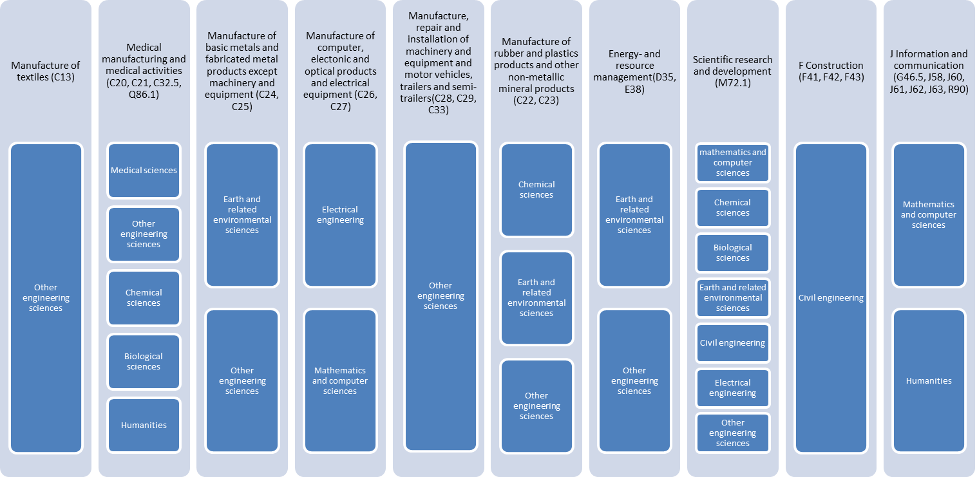
Figure 1: Combination of the chosen fields and sectors of innovation on the basis of fields of innovation

The main fields of innovation with high regional impact are in detail:
- Manufacture of textiles
- Medical manufacturing and medical activities
- Manufacture of basic metals and fabricated metal products except machinery and equipment
- Manufacture of computer, electronic and optical products; electrical equipment
- Manufacture, repair and installation of machinery and equipment; motor vehicles, trailers and semi-trailers
- Manufacture of rubber and plastics products and other non-metallic mineral products
- Energy- and resource management
- Scientific research and development
- Construction
- Information and communication
These fields of innovation have been grown during the last years and show the existing potential of the regions for innovation and growth in the future. As increasing demand for qualified workers within growing fields is expected in the future, activities in knowledge development should be in line with it. The next chapter deals with the situation on knowledge development and examines how regional education systems and activities pepare the existing potential of professionals for the future.

Situation on knowledge development
One consequence of the technological and structural change is the change of the skills profile of the workforce. In the phase of mechanization of the economic development, organizations need different skills than in the phase of rationalization and automation. The Austrian Industry has carried out studies to elicit the future skills profiles of workers in the industry. This study points out significant qualification criteria, which can be divided into five competence areas:
- Process skills: the understanding of processes and their relations supports a holistic view of the business units and thereby making decision-making criteria more transparent.
- I & KT Expertise: Professional use of modern communication and information system is becoming important and indispensable increasingly.
- Economic competence: A fundamental understanding of business management is needed, which is not based solely on cost. Especially the consideration of technical and organizational processes on the basis of business criteria is important.
- Organizational and management skills: Independent work is not only felt by managers. Besides the specialist task management, classical tasks like organizing and regulating are demanded by any employee of a company.
- Activity-based collaboration and communication skills: in the modern work environment the establishment of interdisciplinary cooperation conditions is a growing requirement. These social skills will be of increasing importance in the future.
In addition to these properties, a further requirement has filtered out to employees in the industry: the linking of specialist knowledge with experiential knowledge. It is not enough to simply acquire the above mentioned skills as theoretical knowledge. Theoretical knowledge can only be successfully put in practice when it can be combined experienced knowledge.
Another crucial factor is the ability to learn. A unique phase of training and learning in the information society is no longer sufficient, but must be complemented by an entire working life-long learning. The ability to learn new knowledge and skills is seen as a further depth of expertise. Thus, not knowledge itself becomes a decisive success factor, but the handling of knowledge. The ability to acquire knowledge, to revise and renew the existing knowledge constantly and to apply the learned to problems represents a competitive advantage for future industrial employees.

Education systems and their main challenges
Reviewing the educational system of the investigated countries of the region it is seen that it is rather complex and multilevel. In most countries vocational training appears on several levels of this complex system in conformity with student demands and labour market needs. The greatest emphasis on vocational training is laid on the secondary level of the education system, in vocational training institutions, vocational schools and technical schools.
Apart from rare exceptions, it is essential that the education system should be open to practice-oriented training manifested in education programmes, the organisation of training courses, the selection of practitioner sites and their integration into the education system. It is an important experience of the reviewed cases that economic actors and businesses are interested in participating in the training system both on the level of secondary and higher education. On the basis of the implemented programmes it can be emphasized that mutual interests are very important factors of cooperation.
Several case studies highlighted the importance of national and/or territorial (regional) level strategies in the development of training, professional training system as well as in the development of co-operation. The documents mentioned play an important role in the promotion of trades/professions high in demand in which the promotion of vocational education institutions is also essential. It is important to emphasize the role of informal trainings in vocational training, such as training courses, evening schools, various courses, and training programmes lasting a few months or a few semesters, targeted primarily at people having already a job.
The significance of the private initiate, privately funded institutions that are key players in the vocational training system and in the establishment and development of cooperation with economic operators in the countries involved should also be emphasized. Some case studies in addition to the above-listed facts also emphasise the difficulties and obstacles of the training system. The most important of these factors are as follows:
- the over-bureaucratisation of the education system, its rigidity,
- uncoordinated growth of non-state education (private and church schools),
- uncoordinated introduction of new disciplines and types of schools mainly in years 1991-2000 (e.g. trade and business, technical and IT services),
- financial shortage of funds for schools modernisation,
- the absence of responsibility system,
- low normative per pupil,
- low interest of high potentials because of low image of vocational schools in comparison to grammar schools,
- increase of number of students at low-cost faculties
- underdeveloped HEIs’ (Higher Education Institutions) strategic management

Future Jobs
The change in the world of work has accelerated in recent years. This change creates activities that are not yet certified profession. The requirements for qualifications have increased. The modern world of work is permanently "under construction ". Familiar and manageable structures, professions and functions are increasingly resolved, familiar orientation and identification got lost. The rapid progress in economy, technology and society and also the faster innovation cycles are resulting in new professions and functions, especially in trend-growth industries. The changes in the working world can be described by dominant trends illustrated in the following figure:
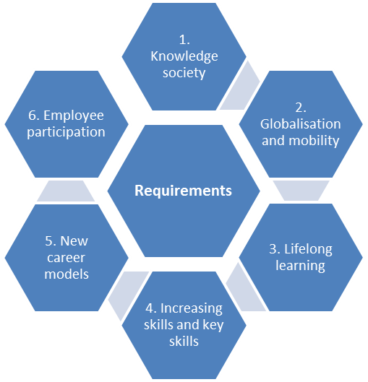
Figure 9: Trends in the world of work
These trends are now some of the most important ones, which take an enormous impact on the working life, the society and the professional orientation. As Economy and society are on the way from the industrial and service oriented economy to a knowledge and information oriented economy employees have to be able to use program-controlled work equipment at very different jobs and in almost all professions. It leads to permanent update of knowledge in order to react on fast changes in innovation right in time. Moreover an increasing demand for practical experience in educational context was examined: e.g. in situational trainings, experienced educators and technical equipment for classrooms etc. This refers especially to adjustment between education and industry and collaboration between different entities is required in the regions in order to connect places where new knowledge is created with educational systems. Furthermore an improvement of monitoring systems was demanded: unified supervision and standard systems to change form and content of training and the possibility for economy to influence the educational offers according their needs.
Also globalization is changing the world of work: adaptability and flexibility are required in order to work for companies which compete at the international market. This introduces further requirements like cross-cultural knowledge, intercultural competencies, linguistically qualifications and awareness rising on the role of the region in an international competitive environment. Regarding lifelong learning, especially informal learning and self-direction in learning are essential. This requires the increasing willingness of employees for continuous improvement as well as support of companies by existing educational institutions (e.g. trainings and studies beside work offered by university).
With regard to innovative companies in future technology fields it was examined that especially interdisciplinary skills and competences become more and more important. Beside the increase of the formal qualification levels non-academic skills and extra-functional skills (key qualifications) become increasingly important: Methods competence (analytical skills, thinking in contexts ...), Social competence (conflict resolution, communication skills, ...) and Self competence (motivation, dedication, persistence, ...).
Furthermore the flexibility of working conditions, especially the timing and frequent of job changes leads to new occupational biographies. Many workers take over their own career development, they pause in pursuit of learning, to regroup or to recover. New measures and instruments need to be developed in order to improve occupational orientation as jobs and professions become more and more diverse. Especially new career models can be the chance to find solutions to promote career planning in line with family planning of women.
Against other trends of project management and reduction of the permanent workforce, there are also some companies which tend build up a permanent workforce. Reasons therefore are simple planning, the permanent availability of specialists and the absence of major organizational coordination work. To retain employees companies often offer attractive factors like so called employee participations. Results should be a stronger commitment of the employees and an increase of sense of responsibility, motivation and entrepreneurial activities of the employees. Another form of employee retention is the increased involvement of employees in important decision-making processes. The independent decision making in addition to the assumption of personal responsibility is now even required by employees. However these models can be found at bigger companies and most SMEs in the regions need to discover it first. These trends are only some of the most important ones, which take an enormous impact on the working life, the society and the professional orientation. They will be considered in measures and instruments to foster high potential development in the participating regions.
To sum up we can categorize the finding in the following groups:
- Shift from full-time employment to part-time employment
- Shift from permanent to occasional, project-type employment
- Shift from fixed workplaces to mobile workplaces
- Shift from single profession, single education to multiple professions and life-long learning.
- Shift from hierarchical management to more flattened and dispersed decision structures.

Cooperation between education and industry
The transfer of results of research and development leads to realisation of innovations - the creation of new products, technologies and processes. Their integration into economy and their process of consummation is often realised by cooperation with companies or founding of new companies. On the other hand regional companies are enabled to participate at new scientific knowledge and developments in order to improve their products or processes. The way of knowledge and technology transfer is often realised by cooperation between institutions in joint research and development projects, practical training for students or joint mentoring of master theses. By integration of students into this process the study reaches a higher level of practical and occupational relation. The integration of practical trainings into study is often realised with regional companies and the university itself is able to meet their mission to educate and prepare their students for work.
During the project different types of cooperation have been analysed in order to examine how a good co-operation needs to be organized, what are the benefits and achievements for the participants and what are important factors to make it sustainable. The results were used to improve the collaboration between different levels of vocational education and qualification and industry.
Figure 10 depicts almost all human resources flows within the regions and also incoming and outgoing migration.
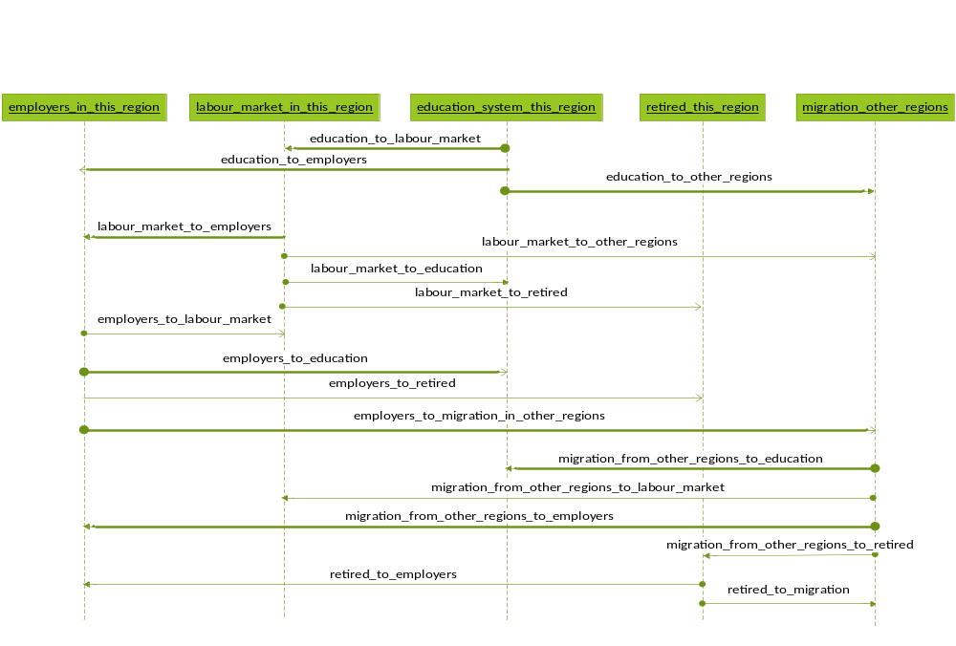
Figure 10: Human resources flows between entities.
Bolded flows on Figure 10 are subject of improved collaboration between different levels of vocational education and qualification and employers:
- education_to_employers; this is preferred flow because employers are closely involved in education.
- education_system_to_labour_market=>labour_market_to_employers; this flow is the most common. The lag should be carefully monitored by education in order to reduce it.
- education_to_other_regions=> migration_to_other_regions=> migration_from_other_regions_to_education; these flows indicate developed students exchange programs. There is a risk that students will migrate in other regions after they complete the studies. However, students that return usually bring new experiences and social network that helps in establishing business with other regions
- migration_from_other_regions_to_education=>education_to_employers; students migrate from other regions often need language training while domestic students often need intercultural skills. Talented foreign students are attracted and employed by regional employers.
- employers_to_education=>education_to_employers; employers often require specialized knowledge and skills offered by education institutions. Usually employees become part-time students although full-time study is not excluded.
- employers_to_labour_market=> labour_market_to_education=> education_to_employers; due to various reasons employers cease the contracts with employees. Usually regional employment offices are necessary to develop and finance/co-finance training and retraining programs for unemployed persons. After completition employment follows.
- employers_to_migration_in_other_regions=> migration_from_other_regions_to_employer; employers send the employees in other region’s education and training institutions or other branches of the company to gain new skills and experiences. After completion employees are better qualified and positioned in their companies.
Fields of measures used for the improved flows are:
- grants, fellowships, scholarships, fees, tuitions, practices, internships, donations, sponsorships
- research and development projects between education and employers
- supporting activities such as: meetings; fairs, consultations; formal programs of collaborations; non-commercial projects between education and employers targeting third party
- award systems implemented by regional employers
- promotion activities, intercultural communication
Table 2 presents the proposed priorities given by project partners for their regions in order to strengthen collaboration between different levels of vocational education and qualification and employers are presented:
 | Fields of measures
Country: Region | A | B | C | D | E
(LP, PP2) GERMANY: SAXONY, Chemnitz | high | high | moderate | moderate | low
SLOVENIA: Zahodna Slovenija, Gorenjska | high | high | moderate | moderate | low
SLOVAKIA:Vychodne Slovensko | high | high | moderate | moderate | low
HUNGARY: DUNANTUL, Közép-Dunátúl | high | high | moderate | moderate | low
ITALY: NORD-OVEST, Piemonte | high | high | moderate | moderate | low
POLAND: REGION CENTRALNY, Łódźkie | high | high | moderate | moderate | low
CZECH REPUBLIC: Severozápad | high | high | moderate | moderate | low
AUSTRIA: Steiermark | high | high | moderate | moderate | low
Table 2. The proposed priorities of the fields of measures in partners regions.
Among the results of the collaboration between the two sectors there could also be the higher cost-effectiveness of joint projects, joint researches, joint training programmes, the reduction of relation building and maintenance costs, the achievement of stated goals, the improvement of the quality of services rendered/used and the generation of unpredicted (or at least unspecified) additional results achieved during the cooperation-project. Additional barrier factors regarding student oriented cooperation and business oriented cooperation have been examined. The barrier factors to cooperation, on the basis of factors outlined in case studies, can be summarised as follows:
- A substantial obstacle to the development of collaborations is the un-motivation, the lack of interest of one of the participants; → Establish a motivating system
- Secrecy in companies: an obstacle which may emerge in case of enterprises is a necessity to retain secrecy regarding their activities. In this case both parties’ aims and expectations differ. Universities deal not only with doing research but also with publicizing its results. In case of companies the most important result is a product or a service, which provides them a competitive advantage against other enterprises. Therefore, the business sector strives for protecting its secrets and is not interested in sharing them with other actors. → create and promote models where cooperation can be tested in order to build up a network basing on formalised structures in order to decrease distrust in cooperation
- Costs incurred by both parties: the representatives of businesses try to estimate the costs of their activities in all their fields, also related to co-operating with universities, and they compare them with potential profits. Too high expenses related to potential benefits may often arise as an obstacle.
→Finding additional financing for co-operation with entreprises
→Elaborating financial mechanisms of support the cooperations
- Limitations of the educational system: curricula were hitherto centrally elaborated educational standards, which made it difficult to modify the offer in accordance with entrepreneurs‘ needs. Level of financing universities is related to the number of students, which decreases the quality.
→ Elaborating a strategy for alternative educational method
- Problems related to intellectual property: in case of cooperation it is not clear who has the rights to use results of the work;
- Lack of modern laboratories: changes in the industry require large scale of investment , which aim is to prepare laboratories in the technical fields to requirements of the changing economy.
→ Finding additional financial support for the development of educational and research infrasturcture
- Lack of university staff’s contacts with business: some of university teachers teach in a way which finds no reflection in practice.
→Putting more emphasis on lecturers‘ didactic competence as well as practical skills and experience of co-operation with enterprises
→Raising quality of human capital at the universities
- Lack of mechanisms and solutions of support of knowledge transfer: universities are demanded to transfer knowledge to the industry, whereas no-one remembers it requires support and legal solutions.
- Lack of practical knowledge of the university staff;
→Organizing workshops by representatives of companies, whose task would be to show how to transfer theoretical knowledge into practice
- Lack of resources in the companies (people, time, money, equipment);
→Finding additional financing support
→Elaborating financial mechanisms of support the cooperations
Unmotivated teacher due to low salaries and personal problems;
→Establishing a motivating system
Measures to implement in Pilot Actions in selected region will include four main types of actions:
- Raising awareness of the issue (demographic change and lack of high potentials) for all relevant stakeholders: regional decision makers, educational institutions, companies (supporting activities like fairs, information for these target groups at events, articles in newspapers, etc.)
- Assisting in establishing cooperation between educational institutions and economy (by developing evaluation tools for cooperation, activities focusing on transparency on regional initiatives to support cooperation)
- Activities focusing on occupational orientation and brain drain for high potentials or becoming high potentials (pupils, students and “young professionals”) (Days of industrial culture, Night of Sciences, event to get to know a branch, joint lectures, mini projects, open days)
- Competence development (further training of employees, new future jobs foresight, prepare SME how to implement apprenticeships)
- Promotion of the region and branches within future fields of technology as an attractive place to work

IDEA Strategy
IDEA follows the approach that innovation, especially the fostering of regional innovative pro-cesses, needs highly qualified networking. The term network in the meaning of IDEA stands for the cooperation between companies, research institutions and universities, political and regional decision makers and social partners unified by the conviction to develop their region and its competitiveness by innovation. Such networks integrate the necessary stakeholders and target groups to implement innovative ideas and to manage the different stages of the innovation process. These structures must have or develop the competencies to define innovative chances for their region and to initiate and control those activities which are necessary to transfer these ideas into real market performances. That means to bring new knowledge into the regional competence centres (e.g. companies, R&D institutions etc.) to generate new innovative approaches and to develop new, high value-added products and services basing on these new approaches.
On the other hand the early definition of innovative chances in the region enables the different decision makers and stakeholders to react proactively with strategic measures and instruments to support the education of the demanded human resources. That is the main task to implement innovative ideas into marketable products and services. If the region is not able to have the right people at the right time the innovation will leave the region to another one having created the necessary preconditions. The brain drain takes place to more attractive regions. Attractiveness in this sense means occupational opportunities and the quality of life as a strong combination. Only the creation of jobs divided from the aspect of the quality of life and vice versa will not attract human potentials or even high potentials to the region.
Education as the basic condition for growth and development has to tie together innovation and human resources by increasing qualification and creation of new competencies. The educational system in the region must be enabled to detect the essential challenges and needs arising from innovative chance and to adapt itself to carry out effective measures in time. The forecast of such challenges and needs can be implemented by the strong cooperation within regional networks and stakeholders. It is necessary to support education to become dynamic in order to react according developing innovative trends proactively. That means that the necessary human resources will be developed at least in parallel to the development of the technical challenges in the regional economy.
In the current situation in the regions there exists a dividing distinction between these three essential parts of the regional innovation system. Each part works for each own. Innovation is seen more or less as a technical dimension, education runs behind political decisions which are often coursed by the current situation and not by the future demands. The human resources are not able to gain benefit from new developments because they are not qualified for these in time. That is the reason for the leaving of innovations out of the region towards regions and countries which have been able to see the chances of this innovation and to offer the appropriate conditions (often far away from Europe).
The strategy of IDEA therefore mainly aims at five strategic fields of action which enable the triple helix of policy, education and industry to face the individual challenges according their individual needs: to identify, to attract, to bind and to develop high potentials, which are supported by framing activities. The following partwill give a short definition on these fields as well as their inherent targets.

Description of strategic goals and defined priorities to reach them
As stated before the strategic fields of action define the major goals of the IDEA strategy. They have been defined according the regional circumstances and the analysed framing conditions. The results are basing on SWOT analyses as well as Good Practice evaluation and testing of improved measures and instruments according the regional needs. According these results final priorities have been defined in order to derive targets and suitable measures. Within these Priorities measures of similar character and with similar aims can be found which may contribute to more than one major goal or target. The structure of the IDEA strategy was prepared by summarizing similar measures to their main target neglecting their added value to other targets or even Priorities.
To identify High Potentials
Most of the measures aim at occupational orientation focus on the possibility to attract high potentials at an early stage of education and cover a broad range of target groups. These activities target pupils or students before they start vocational education or study and try to increase the image of technical education at all. These major goals aim at the increase of the number of students in the MINT (mathematics, informatics, natural sciences and technology) subjects at the universities, vocational schools or technical schools. Furthermore it aims at the increase of the attractiveness of the region and the branch as well as the situated SMEs in order to bind them to the region.
To attract and to bind high potentials
These major goals focus on the attractiveness of the company, the branch or the region. It supports to get in contact with the target group and is long term oriented. Therefore the measurement of results and effects of these activities as well as their sustainability is difficult and not directly visible. These long-term oriented activities aim indirectly at the reduction of the gap between supply and demand of qualification by increasing the number of applicants and students.
To develop high potentials
This major goal aims at the reduction of SMEs demands for specialised knowledge or expertise. Additionally activities in human resource development lead to positive effects for career advancement planning. It aims at reduction of the risk for the enterprise to have a lack of high potentials after retention and it affects on the attraction of new skilled employees as well as to bind high potentials. It focuses on the opportunity for employees to get qualified for more ambitious work or task or to get qualified in a more professional way. It mainly aims at the creation of accompanying structures of qualification in selected technology fields. Activities in this field can be long-term or short-term oriented.
To support the achievement of the other major goals
This field of activity focus on approaches supporting regional organizations and networks focusing on activities regarding demographic change, brain drain and the divergence between supply and demand of high potentials. Regional initiatives are able to support SMEs in implementing several activities of their HR Department and can support SMEs to get in contact with universities, schools or institutions for further education in order to find future needed professionals. The support and initiate these institutions, measures and activities regional framework conditions have to be agreed by government, industry (SME) and training institutions (universities and other education institutions). The legislative framework of the region can be decisive regarding the possibility to attract foreign professionals or even to reduce the barrier (e.g. accepted foreign degrees, immigration rules) between the regions (or the states of Europe or countries outside the EU area).Therefore activities regarding this major goal are very long-term oriented and include also tools for analyses, information, forecasts and evaluation.
The follwoing priorities have been defined in order to meet the objectives of the major goals:
Priority 1: Improvement of career orientation
The Action encompass measures orienting future and present High Potentials towards learning science and technical occupations, which contribute to identification of high potentials e.g. in the scholastic sector. The following targets can be summarised under the major goal to identify young talents:
- Identification at all levels of education by skills and competency assessment, mentoring and coaching → to offer career orientation
- to facilitate children in learning science and technology
- facilitate immigration of highly skilled workers (also from abroad)
- to support students assignment in companies by vocational education
- to offer a holistic career orientation with special regard to future fields of innovation
Priority 2: Promotion of region as an attractive place to work
The analysis of the tested measures indicated that the aims related to attracting and binding of high potentials within a region are very close to one another and much overlapping in terms of activities which may bring to such effects. For that reason it is proposed to combine the activities serving both aims under one Priority. The measures focus majorly on promoting economic potential of local industries and related career opportunities. The following main targets can be summarised:
- To avoid emigration of students/High Potentials
- To increase the attractiveness of social and economic environment
- to support to firms’ research and high potentials career possibilities
- To improve the regional and firms’ competitiveness supporting their innovation
- Creation of joint-ventures, consortium or other firm associations
Priority 3: Developing competencies of present and future High Potentials
The pilot action includes different forms of lectures as well as other kind of programs enabling development of High Potentials competencies in selected areas of engineering occupations. The positive impact on development of High Potentials can be assigned to many other measures, but it can be assumed it is an additional effect / added value of the activities and not the main target. Measures within this priority aim at the following targets:
- To set up accompanying structures of qualification in selected technology fields
- To increase the students / High Potentials / employees / firms' specific knowledge
- To promote apprenticeship, vocational and adult education
- To develop students and High Potential interest in scientific and technical topics
- To increase technology and knowledge transfer
Priority 4: Regional co-operation towards finding, binding, attracting and developing High Potentials
The Priority includes a long list of various initiatives aimed at fostering business to education (secondary, tertiary, vocational) co-operation. The measures vary from activities focused at increasing awareness of future labour market situation, analysis of regional capacities and key determinants of successful co-operation, to promotion of good practices or organization of discussion forums involving different stakeholders.
- to reduce the gap between theoretical education and practical needs of companies
- to foster cooperation between education and industry
- to support the organisation of studies, researches and informative actions supporting the economic development of the territory and to foster the local employment
- To support interventions increasing the firms’ technological innovation
- To set-up of efficient guiding and evaluation system for cooperation between industry and educational institutions
All Priorities can be understood as open priorities according their definition: the indicated measures and instruments have been tested in the project which can not make a claim to be complete. They can be understood as leading examples for identification, attraction and development of High Potentials.

Priorities and Measures
This chapter contains detailed information on the choosen priorities and tested measures and instruments.
Priority 1: Improvement of career orientation
In general, most of the measures used unconventional methods of presenting the specifics of production companies and engineering occupations, which helped to raise target groups’ interest in the subject and stimulate vocational orientation towards industrial sector. The activities were mostly focused on pupils in order to bring them as early as possible in contact with local firms. As declared by partners responsible for the pilot measures they were successful in reaching the expected results (this statement do not apply to Creative Factory project which is still under construction).
According to the data presented in evaluation of the measures the major contribution to identification of High Potentials resulted from actions in the scholastic sector e.g. classified as the use of different techniques to facilitate the children in learning science and technology and offering career orientations. It should be stressed however that implementation of the measures supported promotion of the partner regions, their local companies or industry-related R&D units as attractive places to work. For that reason, most of the activities were regarded as having positive influence on binding and attracting. In this context, the widest range of project’s aims was reached by Measure 23. Geocaching.
Although the activities did not result in establishing networks, they clearly indicated potential benefits of developing cooperation on safeguarding High Potentials by their early vocational orientation. This can be proved for example by a great success of Measure 1. Late Shift… which, due to the fact of being integrated into a larger event as well as cooperation with 18 industrial firms and research organizations, gathered almost 3000 visitors. On the other hand, there was encountered insufficient engagement of schools into the vocational orientation processes, which affected possibilities for developing cooperation between the units as well as brought to difficulties in recruitment for the events. Connecting and interlinking vocational orientation initiatives instead of organizing competing events in the region could lead to more efficiency and effectiveness in this field.
It can be added that in general all partners responsible for activities within Priority 1. got positive feedback from their beneficiaries (e.g. pupils, students) as well as companies, research organizations or other partners involved. As a consequence initial declarations of continuing selected pilot actions in the future were made.
Priority 2: Promotion of region as an attractive place to work
The Priority comprised measures of different character and contrasting a traditional approach to promotion of career opportunities with more extraordinary ideas. On the one hand, promotion of the regional offer was made by participation in job fairs/recruiting days – large events dedicated to employers’ branding. Similarly there were organised lectures presenting success stories of selected start up’s or familiarizing audience with specific activities and development plans of companies operating in the region. Such actions were accompanied with promotion of selected employers by short films. There is also an example of lecture aimed at linking students with regional companies which was organized in the form of Skype lecture. Additionally there was organized an unconventional event - promoting local employment offer during a party dedicated to a group of resident commuters and potential return migrants, visiting their families over the Christmas holiday period
Furthermore most of the initiatives supported all four fields of the priority. The major contribution to bind High Potentials was gained through filling the firms/university gaps by initiatives against the reduction of students / High Potentials emigration and brain drain as well as reduction of the gap between theoretical education and practical needs of companies (in disciplines as mechatronics, information technology, electronics, manufacturing to microtechnology and chemistry). According to the project partners the pilot action attracted High Potentials mainly through supporting for the student’s and HP career possibilities, improving the socio-economic environment attractiveness as well as employees' sustain.
All partners confirmed that implementation of the activities allowed for achievement of the expected results while in some cases the activities also turned out to be a great success. For example the The Coming Home Party (Measure 28.) attendance exceeded initial expectations. After the PA its coordinator got a lot of E-Mails and telephone calls of people who are looking for job positions in the City of Chemnitz and are willing to come back. During the first month after the Christmas campaign the web site’s page views of the skilled personnel portal Chemnitz attracts have nearly doubled...”. Also the film campaign (Measure 22), which shows actual dilemmas of youths and their real families concerning the choice between secondary school and entering apprenticeships promises a big success in reaching the target group by social media: Youtube, Facebook , web blogs, etc. Similarly, the lectures provided under Measure 27. The Skilled Personnel Alliances reached the goal by linking and bringing High Potentials’ in contact with potential employers and additionally by improving the collaboration of firms with higher education institutes. The Measure 31. Organisation of a joint lecture at university proved the effectiveness of video conferencing method. No new networks were established within the Pilot Action – it was mentioned however that implementation of Measure 22. Trainee of the day – documentary film enabled refreshing existing network that is interested / commited to binding and attracting High Potentials. There was also a declaration that cooperation established within Measure 31. is to be maintained also in the future.
Priority 3. Developing competencies of present and future High Potentials.
Although positive influence on development of High Potentials was reported also with regard to other Pilot Actions, such effects were achieved mainly as an added value of their implementation. In contrary, the activities classified within Priority 3 had direct focus on development of particular competencies while additionally contributing to other priorities.
It should be explained that Measure 6. Summer University was planned as an activity aimed at finding more High Potentials at as an early stage of education as possible. In practice however, it addressed more mature people than initially expected and therefore offered them new possibilities to develop their competencies. A double impact of this action may be expected due to the fact that many of the participants have own children and thus first hand influence about their career. In terms of achievement of the assumed results, the measure had a real impact on the world of work. Moreover, the fact that the participants were given certificates, which may help them to find better job even in a future field, makes the effects long lasting. An added value of the measure is that it contributed to creation of a network for two universities and companies to either train or “exchange” their employees.
The workshops organized for students in Slovenia (Measure 25.) gained positive feedback from the majority of employers in the region who stated that the skills presented in the workshop are the ones that the employers seek. The students were provided with knowledge of procedural and project management as well as increased their awareness of the importance of effective organization. Students participated actively and provided a positive feedback as well. Moreover, a follow up of cooperation with the lecturer, Secondary School and higher school is envisaged. It should be noticed, that measures which integrated goals related to up-grading competencies of High Potentials with strategic aims related to development of regional economy have been included. Seminars/meetings addressed to High Potentials representing companies from the region of Alessandria (Measure 7.), enabled participants to develop new skills in field of international trade which may have significant impact on capability of local SMEs to internationalize.
The realization of the Pilot Actions within this Priority created also an opportunity to test innovative methods of developing competencies of High Potentials. In the region of Lodz a program of summer apprenticeships was successfully implemented based upon a method of mentoring. This program got a positive feedback from both mentors and mentees. According to the evaluation the measures major influence on development of High Potentials was achieved through initiatives classified as: increasing the students’ / High Potentials’ / employees’ /firms' specific knowledge; supporting employees' training and development; increasing the firms' technological innovation.
Priority 4. Regional co-operation towards finding, binding, attracting and developing High Potentials.
The measures implemented within the Priority give a lot of attention to analysis of supply and demand of qualifications and related cooperation between education and industry to synchronize them in the regions.
The studies conducted in the region of Chemnitz (Measure 8.) revealed that apart from
a single internet platform there is no central institution to coordinate supply and demand of advanced vocational education. “Regarding the matching process of supply and demand supporting platforms where SMEs and educational institutions meet each other can lead to positive effects within synchronisation of advanced vocational training. SMEs are able to communicate their demands to universities, chambers or other institutions with regard to reach changes in content of study, vocational education or advanced vocational education.” New platforms for information on regional initiatives dealing with these issues should be further supported and ensure high level of transparency to motivate also SMEs for investing in lifelong learning of their employees. Based upon analysis of profile of High Potentials in the region, in order to prevent brain – drain the SMEs should have competitive salaries, a good image, offer possibilities for further qualification and lifelong learning.
Based on SWOT analysis (Measure 13.) conducted in Czech Republic, Slovakia, Hungary, Germany and Poland, the Pilot Action enabled elaboration of a whole series of practical recommendations, observations and proposals regarding developing cooperation between secondary schools and industry. The detailed conclusions from this study are presented in a report “Creation of SWOT Analysis of secondary schools/industry cooperation” prepared by The District Economic Chamber of Most and can be very useful when elaborating the IDEA strategy. Moreover, the analysis enabled practical verification of the methodological concept of SWOT analysis elaborated within the project. The methodology can be used in other regions helping to improve co-operation in this area (secondary schools /industry) and bring together different stakeholders.
Information which may foster future secondary schools/industry co-operation was gathered also within a questionnaire survey conducted in the Czech Republic. The elaborated survey enabled identification of: the major benefits for the schools and students from co-operation with employers; the best forms of such cooperation; factors limiting and stimulating cooperation. According to the study the schools positively evaluate and appreciate the opportunity to be in touch with practice, indicating benefits of such cooperation for both schools and students. Interviewed schools and employers agreed that the best forms
of cooperation are those related to providing professional practice for students
in companies, providing information on job vacancies and cooperation in processing and updating the educational programs. The main factors limiting cooperation between schools and employers are e.g.: poor work morale of students; little motivation for employers, especially among SMEs to work together with schools (a large financial and time burdens); costs of productive work training; lack of state support; workload of employees. The knowledge provides valuable input for the strategy while the questionnaire can be a useful tool for conducting similar analysis in other regions (there has also been elaborated guide notes for applying the survey in other regions).
Similarly, a questionnaire survey on tertiary schools/industry cooperation was elaborated and conducted via web-portal in Hungary (Measures 16 and 19). The study enabled gathering information about general characteristics of the co-operations and assessing their numerical results. In general there is a low number of successful examples of collaborations and an inadequate interest from the side of tertiary institutions (regarding the concrete actions to find potential partners). The study revealed e.g. that: the co-operations between tertiary institutions are not sufficient; most of collaborations are initiated by the industrial actor; the success of the collaborations mainly depends on the personal relations, and on the contact persons; the co-operations with smallest companies has a short-term and occasional character; the key determinant of its success is the active participation all of the stakeholders, etc..
Furthermore the measures had significant contribution to identification and promotion of good practices in business to education co-operation aimed at finding, binding, attracting or developing High Potentials. It was also a platform for discussions concerning mechanisms and processes that could stimulate and improve potential co-operation. In Slovakia, examples of centers of professional education (CPEs) were analyzed (Measure 9.) which represent industry and schools (students and teachers). The results show that the CPEs present real step towards synchronizing education and industry in Eastern Slovakia. It also underlined the importance of developing co-operation with parents who (due to their different – in comparison to students - vision or perception of occupations) may have significant impact on the ability to find, bind or develop High Potentials too.
Another example of good practice delivered by IDEA project, is the web catalogue prepared in the region of Lodz, which describes regional capacities for business-academic co-operation in the field of students’ competencies development (Measure 17). Availability of the information may contribute to not only developing competencies of High Potentials, but also binding and attracting them to the region by creating more opportunities for their professional development.
An interesting example of co-operation which not only helps in identification of High Potentials, but also binds them with a region is the Chambers Approval Certificate, provided in Czech Republic by the Economic Chamber of Most (Measure 14.).
The 7 workshops devoted to discussions on cooperation of secondary schools with industrial companies, which were held in Czech Republic (Measure 11.) led to remaining problems that should be tackled: e.g. lack of experience and low ability of absolvents to adapt to new challenges and requirements, as well as poor knowledge of foreign languages; little interest among companies in organizing apprenticeships for students; companies rarely offer a job to graduated students that completed apprenticeships; students not attending apprenticships’ programmes in companies. Organisation of the Work Group meeting University Industry (Measure 18) in Chemnitz is a good practice example of cooperation between business, regional initiatives and projects with the aim to bind high potentials to the region as well as high potentials themselves. It enabled presentation of regional approaches and projects seeking cooperation with business as well as informing SMEs about new possibilities for finding and binding young talented people.
The following figure 11 is giving an overview abbout the defined priorities and fields of activity.

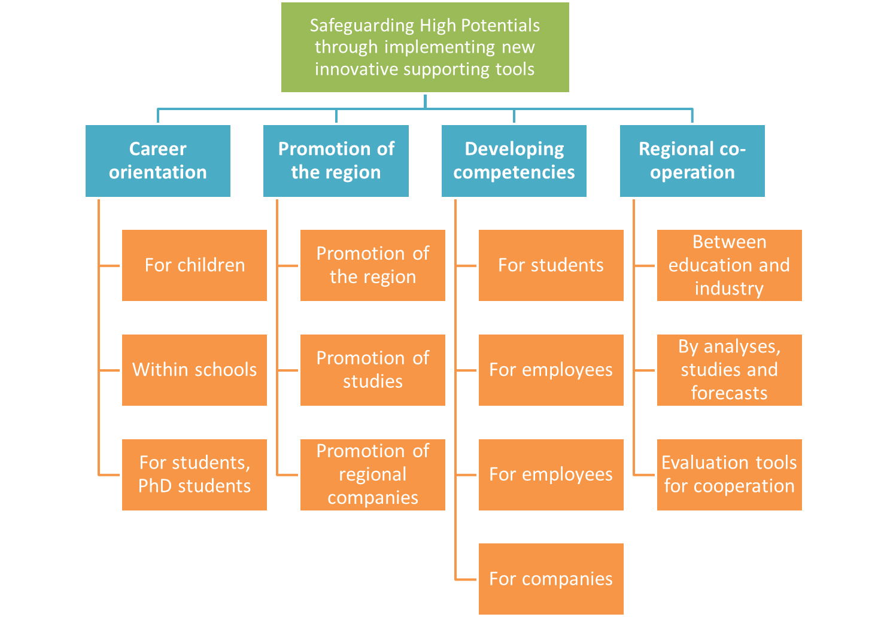
Figure 11: The structure of IDEA strategy.

Prority 1: Career Orientation, Measures focusing on career orientation for children
Measure 2. | Early Shift under the Days of Industrial Culture
Pilot Action: | 5.1 Future-oriented technology innovation development for SME
Coordinator: | Chemnitzer Wirtschaftsförderungs- und Entwicklungsgesellschaft mbH, Germany
Aim: | The aim of the action was to intensify vocational orientation among youths by visiting companies and publicly financed research institutes. The event aimed at improving and developing interest for technical occupations.
Brief description of Pilot Action | At Chemnitz University of Technology 18 schoolchildren aged 9 to 10 could experience the world of sustainable energy and mobility. Here, in the university laboratory “Wonderland” the little scientists were shown experiments to teach them the power of green energy, to spark the interest for natural science and to wake up the inventive genius of the children. The actions helped to get children active outside school by arranging lessons vivid and interesting.
Dates: | 14-09-2012 | Duration: | One day
Target group: | schoolchildren from the primary school | Direct reach: | 18

Prority 1: Career Orientation, Measures focusing on career orientation for pupils
Measure 1. | Late Shift under the Days of Industrial Culture
Pilot Action: | 5.1 Future-oriented technology innovation development for SME
Coordinator: | Chemnitzer Wirtschaftsförderungs- und Entwicklungsgesellschaft mbH, Germany
Aim: | Sensitize and attract people who are interested in technology and production processes.
Brief description of Pilot Action | During the Days of Industrial Culture all who were interested in technology and production processes could visit 18 industrial firms and research organizations. The visitors were provided with the opportunity to watch working machines and staff at the last shift at work.
Dates: | 14-09-2012 | Duration: | one day
Target group: | local community | Direct reach: | 3000
Measure 3. | Night of Sciences
Pilot Action: | 5.1 Future-oriented technology innovation development for SME
Coordinator: | Technical University of Košice, Slovakia
Aim: | Rise interest of young people to start a study in technical fields.
Brief description of Pilot Action | Night of Scientists in Košice was organized in two places in Košice and in the many stalls. Stalls were expositions of several institutions such as: University of Pavol Jozef Šafarik or Technical University of Košice or RWE Company and many others. Pupils had been encouraged to take part in experiments. Flyers, posters were a sort of memory to take away for pupils and also their teachers, who advised students. Interactions took place since ten o`clock in the morning till late midnight.
Dates: | 23-09-2011 | Duration: | one day
Target group: | non-academic, i.e. job and study advisors, teachers and their students | Direct reach: | No info

Measure 4. | Theatre of Engineers
Pilot Action: | 5.1 Future-oriented technology innovation development for SME
Coordinator: | Central Transdanubian Regional Innovation Agency (CTRIA), Hungary
Aim: | The core aim of this PA was the occupational orientation with an enjoyable play and to highlight the existing gap between the labour market and demand of the employers.
Brief description of Pilot Action | In the Central Transdanubian Region there was organised a play „Theatre of Engineers – or the suitcase scooter and the xanaxes”. The play showed the beauty of the engineer profession and the biggest engineering jobs around the world; The story was running on three lines, finally these lines are met, and the perfect engineering product, the suitcase scooter got ready.
Dates: | 30-01-2012 | Duration: | One day
Target group: | youth with technical interest, especially students from six local secondary grammar schools | Direct reach: | 92 viewers
Additional comments | Costs: 4203 EUR

Measure 23. | Geocaching
Pilot Action: | 5.5. Regional approach to deal with brain-drain the "Diaspora-Option" versus "Reverse-Option"
Coordinator: | Chemnitzer Wirtschaftsförderungs- und Entwicklungsgesellschaft mbH, Germany
Aim: | Intensify vocational orientation and to sensitize pupils to regional job opportunities.
Brief description of Pilot Action | There was organized a tour planned as electronic scavenger hunt with GPS receivers through the City of Chemnitz. The game worked as follows: The pupils needed to solve tricky riddles about the regional IT branch in order to get the GPS coordinates for certain stopovers. These coordinates have been sought out with the help of the GPS handheld receivers. On location they get information about working-related tasks of local IT firms and activities of each company. In the aftermath they had to answer a question in order to get the coordinates for the further goal, another stop. Each stop was devoted to different aspects of IT companies management. The game familiarized pupils with the specifics of regional IT branch and different aspects of IT companies management.
Dates: | 13-07-2012 | Duration: | one day
Target group: | schoolchildren of the grammar school (German: Gymnasium) of Burgstädt | Direct reach: | 29 participants

Prority 1: Career Orientation, Measures focusing on career orientation for students and PhD students
Measure 26. | Workshops within a Day of robotics
Pilot Action: | 5.5. Regional approach to deal with brain-drain the "Diaspora-Option" versus "Reverse-Option"
Coordinator: | Business Support Centre ltd, Kranj
Aim: | Introducing young people to the technical professions; Presentation of employment possibilities in deficient fields; Obtaining the best students from primary schools and include them in occupations in shortage.
Brief description of Pilot Action | Within the Day of Robotics (Robotkov dan), BSC together with voluntary support of professors from Technical School Centre Kranj organized practical workshop presenting different areas of technical sciences: mechatronics (drawing of models with program Solid Works), robotics (programming and testing of the robot), energetics (wiring for the light), pneumatics (simulation of the pneumatic system), computer science (making a simple computer game, work with Linux system).
Dates: | 29-11-2012 | Duration: | One day
Target group: | Students of primary schools from Gorenjska region, their teachers and parents | Direct reach: | 150 participants of workshop; 300 visitors of the Day of robotics
Additional comments | Costs: 6000 EUR

Measure 3. | Night of Sciences
Pilot Action: | 5.1 Future-oriented technology innovation development for SME
Coordinator: | Technical University of Košice, Slovakia
Aim: | Rise interest of young people to start a study in technical fields.
Brief description of Pilot Action | Night of Scientists in Košice was organized in two places in Košice and in the many stalls. Stalls were expositions of several institutions such as: University of Pavol Jozef Šafarik or Technical University of Košice or RWE Company and many others. Pupils had been encouraged to take part in experiments. Flyers, posters were a sort of memory to take away for pupils and also their teachers, who advised students. Interactions took place since ten o`clock in the morning till late midnight.
Dates: | 23-09-2011 | Duration: | one day
Target group: | non-academic, i.e. job and study advisors, teachers and their students | Direct reach: | No info

Prority 2: Promotion of the region as an attractive place to work, Measures promoting the region
Measure 28. | Coming home party
Pilot Action: | 5.5. Regional approach to deal with brain-drain the "Diaspora-Option" versus "Reverse-Option"
Coordinator: | Chemnitzer Wirtschaftsförderungs- und Entwicklungsgesellschaft mbH, Germany
Aim: | Attract the peoples’ attention to the occupational opportunities in the City of Chemnitz. Potential returnees and resident commuters could be sensitized in this respect to think about searching a new job in their hometown.
Brief description of Pilot Action | The CWE organized the Coming Home Party under the Christmas campaign to further promote the skilled personnel portal “Chemnitz attracts”. As part of the campaign a Talk Lounge was rented in the Club Del Sol directly connected with the dance floor to advertise the IDEA project and to promote the various job opportunities in the City of Chemnitz. The party was held under the motto “Coming Home – Reunion brings Joy”. Two employees of the CWE answered the questions of all interested people including tips about the current labour market and earning opportunities, distributed promotion leaflets and partied together with the crowd.”
Dates: | 25-12-2011 | Duration: | one day
Target group: | Resident commuters and potential return migrants | Direct reach: | 500 participants

Priority 2: Promotion of the region as an attractive place to work, Measures promoting studies
Measure 30. | Participation in Academic Job Fairs
Pilot Action: | 5.5. Regional approach to deal with brain-drain the "Diaspora-Option" versus "Reverse-Option"
Coordinator: | Technical University of Lodz & The City of Lodz Office
Aim: | Promotion of project’s offer especially with regard to summer internships.
Brief description of Pilot Action | Representatives of IDEA promoted the project’s offer within one of the most important recruitment events in Poland. The Event combines fairs and special workshops for students regarding the development of hard and soft skills, or giving knowledge about effective job searching. IDEA’s representatives informed about ‘innovative internships’ planned for summer and promoted project’s Facebook profile, each week providing its fans with most interesting news on innovations, high potentials, creative ideas and job perspectives.
Dates: | 27-03-2012 | Duration: | One day
Target group: | Students/ graduates | Direct reach: | Approx. 1200 visitors of Academic Job Fairs

Measure 5. | Lectures provided within the Festival of Science, Technology and Art
Pilot Action: | 5.1 Future-oriented technology innovation development for SME
Coordinator: | The City of Lodz
Aim: | Familiarizing young people with examples of successful start-ups of web business in the region and increasing their interest in IT related occupations.
Brief description of Pilot Action | The festival is held since 2001 and is aimed at popularizing scientific and artistic achievements and showcasing the city's university colleges and research institutions by making them publicly available. During the event there was provided a cycle of lectures „IDEA for the future. From idea to business – examples of inspiring careers”, presenting case studies of successful web businesses.
Dates: | 19-04-2012 | Duration: | One day
Target group: | youth with technical interest | Direct reach: | c.a. 40

Prority 2: Promotion of the region as an attractive place to work, Measures promoting regional companies
Measure 22. | Trainee of the day – documentary film
Pilot Action: | 5.5. Regional approach to deal with brain-drain the "Diaspora-Option" versus "Reverse-Option"
Coordinator: | ICS Internationalisierungscenter Steiermark GmbH, Austria
Aim: | To support the measures of professional orientation together with the “Global players” within the region of eastern upper Styria.
Brief description of Pilot Action | There were produced several short films (all in all 28 are planned) promoting Austria as an example of good practice in terms of organisation of apprenticeships. The films present apprenticeships, training and professional career opportunities within the workplaces and additional support services of companies. The main actors are trainees, students, employees and entreprenerus within the region of eastern upper Styria.  The films are published both in television, the internet website, including social media (Facebook, Youtube) as well as via project promotions and co-operating company networks.
Dates: | n/a | Duration: | n/a
Target group: | Young people, before they decide their profession as well as their parents and grandparents. | Direct reach: | n/a

Measure 27. | Skilled personnel alliances
Pilot Action: | 5.5. Regional approach to deal with brain-drain the "Diaspora-Option" versus "Reverse-Option"
Coordinator: | Chemnitzer Wirtschaftsförderungs- und Entwicklungsgesellschaft mbH, Germany
Aim: | Informing students about potential local employers
Brief description of Pilot Action | A cycle of lectures within “IT Alliance for Specialists” and “Engineering Alliance for Specialists” was provided at Chemnitz University of Technology. The lectures are aimed at informing students about potential local employers - companies of the IT branch and firms of mechanical engineering and plant construction present research and development results. This means that the companies inform about actual topics, projects and themes varying from technical problems and approaches to solutions and vision for the future, In principle, the skilled personnel alliances are simply networks of several companies and Chemnitz University of Technology targeting students in the appropriate disciplines.
Dates: | The “IT Alliance for Specialists” has been started in autumn 2007 while the “Engineering Alliance for Specialists” in autumn 2011. Since that time a couple of lectures seminars take place every year. | DURATION | n/a
Target group: | Students | DIRECT REACH: | Approximately 30  students enrolled in each lecture.

Measure 29. | A Recruiting Day
Pilot Action: | 5.5. Regional approach to deal with brain-drain the "Diaspora-Option" versus "Reverse-Option"
Coordinator: | Technical University of Košice, Slovakia
Aim: | Showing to migrated people new job perspectives in the region and to convince them to come back to their home town
Brief description of Pilot Action | “iKariéra - The Day of Opportunities” was a job fair organised in the library of the Technical University. Students and alumni had the opportunity to establish contacts with regional companies via consulting or business presentations. 20 important companies attended the fair as well as more than 350 students and alumni.  Recruiting days are commonly taking place in Košice and Bratislava for instance during April 6th -7th, 2011 and March22nd, 2012. Days of career was the official title of Recruiting Day. These are taking place annually for 17 years. The main organizer is AIESEC.
Dates: | 06-03-2012 | Duration: | one day
Target group: | Students and alumni | Direct reach: | 350 participants

Measure 31. | Organisation of a joint lecture at university
Pilot Action: | 5.5. Regional approach to deal with brain-drain the "Diaspora-Option" versus "Reverse-Option"
Coordinator: | SC Kranj in co-operation with BSC, Faculty for organisational science and companies; Slovenia.
Aim: | To provide connection between students and industry.
Brief description of Pilot Action | 3 companies of the same branch (Telekom Slovenija d.d.; Result d.o.o.; Renderspace d.o.o.) organised a joint lecture at university to teach the students about projects in their daily business life. The lecture provided students with an opportunity to get in contact with experts from industry, and gain first-hand information about the companies they represent. The experts from different technological fields talked about their work in industry. The meeting was organized in the form of a video conference »Skype lecture«. The participating students gained a new insight into their employment prospects.
Dates: | 19-03-2013 | Duration: | One day
Target group: | faculty and secondary school students | Direct reach: | 72

Prority 3: Developing competences of present and future High Potentials, Measures focusing on students
Measure 6. | Summer University
Pilot Action: | 5.1 Future-oriented technology innovation development for SME
Coordinator: | Technical University of Košice, Slovakia
Aim: | The purpose is to give an opportunity to begin a career in IT for young people whose educational focus is not science but they are interested in this area.
Brief description of Pilot Action | "Summer University" was addressed to students who want to learn operating systems and SAP databases. Participants were given certificates, which may help them to find better job, even in a future field. For some students had “gaps” in IT knowledge and some in language etc. this was an opportunity to balance, synchronize their talents.
Dates: | from 02-07-2012 to 20-07-2012 | Duration: | 18
Target group: | Students interested in SAP | Direct reach: | 40

Measure 25. | Workshops for students
Pilot Action: | 5.5. Regional approach to deal with brain-drain the "Diaspora-Option" versus "Reverse-Option"
Coordinator: | Business Support Centre ltd, Kranj
Aim: | Acquainting students with the concepts of procedural and project management in order to increase their employability.
Brief description of Pilot Action | BCS in co-operation with the School Centre Kranj organised two workshops familiarizing students with Procedural Management (basing upon example of car industry) and Project Management (basing upon example of mechatronics) as well as acquainting them with the importance of effective organization. The skills are indispensable in today’s entrepreneurship while the new knowledge gained during the workshops will be applied in the school work so students and teachers will be able to upgrade the quality of their work.
Dates: | 21-02-2013 | Duration: | one day
Target group: | Students of Technical Grammar School (Procedural Management) ; students of Secondary School of Economics (Project management) | Direct reach: | 75

Prority 3: Developing competences of present and future High Potentials, Measures focusing on high potentials
Measure 7. | Organizational innovation for firms of the Municipalities of Alessandria
Pilot Action: | 5.1 Future-oriented technology innovation development for SME
Coordinator: | Municipality of Alessandria, Italy
Aim: | The initiative aimed to promote management innovation in the firms of Alessandria area through “the rise of the number of High Potentials having special expertise in future fields of innovation” already included in the productive tissue. Internationalisation of SMEs was given special focus.
Brief description of Pilot Action | The main idea of this action was to organize 4 meetings for operators who have high qualified professional potential that will stimulate and develop management innovation. “Their aim was to: 1) come into contact with foreign markets 2) promote their commercial products on a large scale thanks to an effective strategy and held down costs 3) provide a series of contractual instruments to transform contacts created in trade, away from the danger of International contracts 4) protect the identity of own products beyond national boundary.” The meetings comprised the following subjects: “Working efficiently with foreign markets”, “Using internet for marketing”, "How to protect innovation”, “International contracts”.
Dates: | 22-11-2011; 07-02-2012; 15-03-2012; 03-04-2012 | Duration: | one day each event
Target group: | Representatives of business sector | Direct reach: | n/a
Prority 3: Developing competences of present and future High Potentials, Measures focusing on employees

Prority 3: Developing competences of present and future High Potentials, Measures focusing on companies
Measure 21. | Innovative apprenticeship programme in regional SMEs
Pilot Action: | 5.4. Development of (trans) regional cooperation between tertiary education/industry
Coordinator: | Technical University of Lodz & City of Lodz Office, Poland
Aim: | Evaluate mentoring-based internships in terms of improving traditional system of internships.
Brief description of Pilot Action | There was organized and tested a mentoring based programme of summer internships in 7 local SMEs. 11 students completed the in-company trainings, and gained new knowledge, know-how and competences/skills by direct learning from their mentors. For each student an individual mentor was provided by companies participating in the action. The main tasks of the mentors were: elaboration of internships’ programme/scheldue, organization of trainee’s work, introduction of trainee into company’s environment including team, daily support in performing trainee’s professional tasks and their monitoring, monitoring of competences’ development. The final stage of internships included evaluation of its performance in terms of mentor-mentee cooperation, trainee’s competence development, system of monitoring, usefulness of such form of practices both for student as well as for the involved company.
Dates: | July – August 2012 | Duration: | 2 months each
Target group: | Students/high potentials | Direct reach: | 11

Prority 4: Regional cooperation towards finding, binding, attracting and developing high potentials, Measures fostering cooperation between education and industry
Measure 14. | Chambers Approval Certificate
Pilot Action: | 5.3. Development of (trans)regional cooperation between secondary education/industry.
Coordinator: | District Economic Chamber of Most, Czech Republic
Aim:
Brief description of Pilot Action | The Chambers Approval Certificate („ChAC“) is the document delivered by chamber of commerce as confirmation of quality and professional skills of a worker who enters for the first time the labour market. The Chambers Approval Certificate („ChAC“) is handed on selected school leavers in cooperation with the school or university to certify and confirm knowledge of graduate in given branch as contribution to identification of „high potentials“ in the region. The Chamber of Commerce helps to mediate a work for a holder of ChAC for a period of at least one calendar year, publishes and presents holder of the ChAC on a dedicated list, recommends ChAC holders to potential employers.
Dates: | n/a | Duration: | n/a
Target group: | Graduates of schools; important representatives of policy makers, entrepreneurs/employers, managers of schools and universities; | Direct reach: | n/a

Measure 15. | Design and development of a web-based platform for support of the regional networking
Pilot Action: | 5.4. Development of (trans) regional cooperation between tertiary education/industry
Coordinator: | Institute of Mechanical and Plant Engineering Chemnitz e.V.
Aim: | Informing about initiatives and projects which support knowledge development in the region of Chemnitz.
Brief description of Pilot Action | In the region of Chemnitz the web-based platform will serve mainly as supporting instrument for regional SMEs to gain information what initiatives and projects support knowledge development in the region. It will be also available for students and pupils to be informed about associations of SMEs, possibilities to participate at regional projects for occupational orientation, to find a study or a job and to get to know all possibilities offered in the region. This web-page should be combined with the event “Work Group meeting University Industry” as it serves as the main regional tool for communication and dissemination and it will bring together not only university industry but also other regional public and private institutions from educational and economy side to ensure regional transparency on this issue. The institutions are enabled to communicate their evaluation results which can lead to a well-developed benchmarking of these regional project: in the end it is clearly defined which institution can offer which competences in this field and fits the company’s imagination how to find, bind and develop high potentials at its best.
Dates: | n/a | Duration: | n/a
Target group: | Business, students, pupils | Direct reach: | n/a

Measure 18. | Work Group meeting University Industry
Pilot Action: | 5.4. Development of (trans) regional cooperation between tertiary education/industry
Coordinator: | Institute of Mechanical and Plant Engineering Chemnitz e.V.
Aim: | Presentation of regional approaches and projects seeking cooperation with business as well as informing SMEs about new possibilities for finding and binding young talented people. The information is about new structure in studies or additional offers of university to support regional companies.
Brief description of Pilot Action | There were organized two events called “Work Group meeting University Industry” which gathered regional SMEs, regional initiatives and projects with the aim to bind high potentials to the region and to enable them to start a career at a regional company. The third part consisted of the high potentials themselves. During the last two events students and PhD students took part at the discussions as they are the target group of nearly all activities and should be integrated from the beginning.
Dates: | n/a | Duration: | n/a
Target group: | SMEs, young talented people | Direct reach: | n/a

Measure 20. | Professional communication platform
Pilot Action: | 5.4. Development of (trans) regional cooperation between tertiary education/industry
Coordinator: | Central Transdanubian Regional Innovation Agency Nonprofit Ltd. (CITRIA), Hungary
Aim: | Fostering regional co-operations
Brief description of Pilot Action | Launch of web-page platform facilitating gathering information about existing co-operations as well as disseminating the IDEA project and its results; country: Hungary.
Dates: | n/a | Duration: | n/a
Target group: | n/a | Direct reach: | n/a

Priority 4: Regional cooperation towards finding, binding, attracting and developing high potentials, Measures conductign analyses, studies and forecasts
Measure 8. | Analysis of specifics of the regional vocational education and demand for high potentials
Pilot Action: | 5.2. Synchronizing regional capacities of advanced vocational training facilities and regional demand for High Potentials
Coordinator: | Institute of Mechanical and Plant Engineering Chemnitz, Germany
Aim: | To analyse advanced vocational education offer in the region in the context future demand for certain jobs.
Brief description of Pilot Action | In the region of Chemnitz there were conducted: a) qualitative interviews with regional experts from private institutions, university and SMEs aimed at identification of problems and barriers of advanced vocational education; b) expert interviews to gain information about new products and processes in the companies and their need for new qualification offers.
Dates: | n/a | Duration: | n/a
Target group: | n/a | Direct reach: | n/a

Measure 9. | Analysis of CPEs and other good practices
Pilot Action: | 5.2. Synchronizing regional capacities of advanced vocational training facilities and regional demand for High Potentials
Coordinator: | Technical University of Košice; Slovakia
Aim: | Identify and evaluate successful models of school-industry co-operations contributing to providing education accustomed to the needs of industry.
Brief description of Pilot Action | There was conducted an analysis of practices and barriers towards synchronizing education, industry and services in favor of high potentials development. The studies were conducted in Eastern Slovakia and their major focus was on activities of selected Centers of Professional Education (established by secondary schools). The studies also covered discussions concerning other successful examples of school-company co-operations as well as different job attitudes represented by students, their parents and teachers.
Dates: | n/a | Duration: | n/a
Target group: | n/a | Direct reach: | n/a

Measure 10. | Future jobs foresight
Pilot Action: | 5.2. Synchronizing regional capacities of advanced vocational training facilities and regional demand for High Potentials
Coordinator: | Technical University of Košice; Slovakia
Aim: | To identify future demands for certain occupations
Brief description of Pilot Action | Changes in demand for selected occupations were analysed in Slovakia as well a case analysis for wood carving profession was made.
Dates: | n/a | Duration: | n/a
Target group: | n/a | Direct reach: | n/a

Measure 11. | Workshops on "Cooperation of Secondary Schools with Industrial Companies"
Pilot Action: | 5.3. Development of (trans)regional cooperation between secondary education/industry.
Coordinator: | District Chamber of Commerce Most, Czech Republic
Aim: | The main aim of the pilot action was an organization of workshops enabling stakeholders’ discussion on issues the possibilities and obstacles of business and schools cooperation.
Brief description of Pilot Action | There were organization 7 workshops devoted to cooperation between secondary schools and the industrial enterprises. During the meetings stakeholders discussed on cooperation of secondary education and industry. Workshops “were based on a network of so-called „Professional Sections“ - a platform gathering 14 expert groups, covering the majority of industrial and educational activities of the region. These sections have permanent members - representatives (managers, directors) of major regional companies, directors of secondary schools and universities, prominent businessmen.
Dates: | 17-05-2011; 01-11-2011; 12-12-2011; 23-04-2012; 27-09-2012; 10-10-2012; 21-11-2012 | Duration: | one day each workshop
Target group: | Professionals from companies/schools/ regional institutions involved in the issue of inter-sector co-operation (e.g. labor office, municipality, etc.). | Direct reach: | 77 [all 7 workshops]

Measure 12. | Elaboration of questionnaire survey
Pilot Action: | 5.3. Development of (trans)regional cooperation between secondary education/industry.
Coordinator: | District Economic Chamber of Most, Czech Republic
Aim: | To create and verify a questionnaire focused on the analysis of the secondary schools in terms of their co-operation with business. Provide policy makers, managers of industrial enterprises, managers of the secondary schools, and students/high potentials with the information that is useful for further decision making and planning of future strategic decisions.
Brief description of Pilot Action | A questionnaire survey focused on cooperation between the secondary education and the industry was elaborated and tested in the Ústí Region. Apart from gaining insight into the existing and desired cooperation models the pilot implementation of the survey enabled drawing up recommendations for other partners/regions; The Questionnaire was focused on exploring fundamental aspects of company and the secondary school cooperation. Content of questionnaire was intensively discussed in workshops and bilateral discussions. Resulting this, the questionnaire contained a total of 21 complex issues/questions.
Dates: | 10-2011 | Duration: | n/a
Target group: | employers, schools | Direct reach: | approx. 350 respondents

Measure 13. | SWOT analysis of secondary schools/industry cooperation
Pilot Action: | 5.3. Development of (trans)regional cooperation between secondary education/industry.
Coordinator: | District Economic Chamber of Most, Czech Republic
Aim: | To develop a practical verification of methodology of SWOT analysis, which should help to improve cooperation between secondary education and industry. It should also provide stakeholders (policy makers, managers of industrial enterprises, managers of secondary schools as well as students/high potentials) with information that is useful for further decision making and planning their future strategic decisions.
Brief description of Pilot Action | There was developed a methodological concept and carried out pilot implementation of SWOT analysis focused on cooperation between high schools and industry. The analysis were conducted in Czech Republic and selected partner regions: Slovakia (Technical University of Kosice), Hungary (Central Transdanubian Regional Innovation Agency). Germany (CWE - Economic Development Corporation) and Poland (Technical University of Lodz). In order to look at this issue from different perspectives, while respecting regional specificity, and on the other hand working out solutions applicable not only in the participating regions, in each of the regions the activities were carried out in a slightly different ways and on different occasions.
Dates: | n/a | Duration: | n/a
Target group: | n/a | Direct reach: | n/a

Priority 4: Regional cooperation towards finding, binding, attracting and developing high potentials, Measures focusing on development of evaluation tools for cooperation
Measure 16. | Development of a web-page to evaluate co-operations
Pilot Action: | 5.4. Development of (trans) regional cooperation between tertiary education/industry
Coordinator: | Central Transdanubian Regional Innovation Agency Nonprofit Ltd. (CITRIA), Hungary
Aim: | The tool was designed to facilitate the process of gathering information about existing co-operations in the region
Brief description of Pilot Action | To make easier and increase the availability of the evaluation toolbox, CTRIA created a webpage (http://idea2010-web.sharepoint.com) where the members of collaborations could use the web-page to complete an on-line assessment questionnaire and get information regarding the weak and strong points of their common activities.
Dates: | n/a | Duration: | n/a
Target group: | All interested groups of stakeholders | Direct reach: | n/a

Measure 17. | Web page: catalogue of good practices
Pilot Action: | 5.4. Development of (trans) regional cooperation between tertiary education/industry
Coordinator: | Technical University of Lodz, Poland
Aim: | Stimulating business interest in cooperation with tertiary units in the field of students’ competencies development by making academic offer more transparent and business friendly.
Brief description of Pilot Action | There was elaborated a web catalogue presenting opportunities for business-academic cooperation in the field of students’ competencies development. The catalogue presents a consolidated contact list with cooperation offers gathered from tertiary units. In order to facilitate the webpage navigation initiatives are categorized in relation to: areas of cooperation, branches and specialization.
Dates: | n/a | Duration: | n/a
Target group: | n/a | Direct reach: | n/a

Measure 19. | Elaboration of questionnaire to evaluate and collect the co-operations
Pilot Action: | 5.4. Development of (trans) regional cooperation between tertiary education/industry
Coordinator: | Central Transdanubian Regional Innovation Agency Nonprofit Ltd. (CITRIA), Hungary
Aim: | Analysis of the cooperation between business and tertiary units.
Brief description of Pilot Action | There was developed a frame of a questionnaire which enabled gathering information about general characteristics of the co-operations and assessing their numerical results
Dates: | n/a | Duration: | n/a
Target group: | universities, enterprises, employment offices: | Direct reach: | n/a

Final Recommendations
The analysis of results and experiences related to implementation of the Pilot Actions and measures they comprised, provide valuable conclusions enabling formulation of recommendations for the joint IDEA strategy.
1) Kids and pupils in central focus
Initiatives which were addressed to kids and pupils appeared to be very successful. There are many possibilities of familiarising this group with the specifics of production companies and gaining their interest in new technologies and the engineering professions. Moreover kids and pupils truly engage in the initiatives offered to them which facilitates the process of building relations between them and local companies, industries, etc.

2) Promoting companies’ initiatives which address secondary schools
In general, companies have still lower interest in developing cooperation with secondary schools than with tertiary units. The potential for developing High Potentials and their vocational orientation before they choose tertiary education is barely used, while effectiveness of such measures being relatively high. Moreover at this stage of their career orientation/development there is a possibility to significantly influence the career decisions by targeting parents and grandparents.

3) Development of competencies within education sector to cooperate with business
One of the major success factor for developing co-operation between business and schools are personal competencies of persons responsible for the contacts. At the same time lack of such competencies on the side of education is one the frequently mentioned barriers towards successful co-operation. For that reason it would be recommended to support measures that facilitate development of qualifications necessary to establish and maintain good relations with business, among personnel of schools. Alternatively there could be considered initiatives aiming at development of dedicated units, within organizational structures of schools.

4) Creating tools and incentives for companies to share their expectations with regard to present and future profiles of competencies
In general the existing co-operations between education and industry are insufficient in terms of adjusting vocational trainings to the market needs. In this circumstances there could be considered development of some system approach that would provide some incentives (e.g. tax) for business to share their expectations related to qualification needs in certain vocations. Another option might be provision of web portals/tools facilitating the process of companies’ reporting on competence profiles needed.

5) Using the activities already existing in the region to reach the target groups.
Both schools and business have limited resources (financial and human) that may be deployed to organization of events dedicated to High Potentials. An effective solution, which have proven to be successful within IDEA project is organization of smaller initiatives (lessons, workshops, exhibitions, open days, etc.) as part of some larger regional events. Such approach is usually more cost effective, has higher potential in terms of gaining interest of companies to participate and supports recruitment processes by interlinking communication about both events.

6) Choosing unconventional measures of presenting industries/ engineering occupations / using fun to gain interest and engagement of target groups.
All measures which used unconventional forms of presenting the specifics of engineering companies and used fun to teach or attract the target’s group attention worked out very well. In the times of flood of conventional communications this approach is very effective.

7) Use the opportunity to get in contact with potential return migrants when they visit their families.
The example of “Coming home party” shows that Christmas time offers a great opportunity to get in contact with those who migrated from the region. It also proves that in-formal communication campaigns are very effective.

8) Maintaining co-operations established with companies
The project’s analysis and practical examples show that the life cycle of business to education co-operation initiatives is short (especially with regard to SMEs), and very often limited exclusively to realization of single events. It would be recommended for education units to implement measures which would help them to maintain an on-going contact with business on a daily basis once the co-operation is established.

9) Lobbying towards governmental schemes supporting organisation of internships
Implementation of the project disclosed a need for introducing some system solution which would facilitate organisation of internships in companies. On the one hand there would be needed some incentives (e.g. tax discounts) for companies to organise practices for student/pupils. On the other hand there would be needed a solution to the problem on the side of schools - internships must be organised in the summer period in order to avoid students’ absence in the school classes. Further investigation of potential solutions to that conflict is needed.

10) Promotion of mentoring based approach to organisation of internships
The example of innovative internships organised in Poland proves high effectiveness of using mentoring in the process of realisation of internships. This approach is not only beneficial to mentees but also increases companies’ ability to make better use of the potential and competencies of participants of such programs, which increases companies’ satisfaction with offering such possibilities to youths.

11) Increasing the use video communication in reaching the target groups
Due to a dynamic development of social media the video communication becomes not only more affordable but also more effective in terms of reaching the target group (High Potential). It is recommended to intensify use of this medium in promoting regions, local industries, local job opportunities or engineering professions.
12) Continue promoting successful examples of business to education co-operations
In this process it can be recommended to increase the use of existing web portals instead of creating a new ones, as well as intensify use of social media.

13) Support and promote SMEs to education co-operation
Due to their very limited resources SMEs are rarely perceived as attractive partners to education and most examples of successful co-operations is based upon well known companies. In fact however SMEs are majority of companies on the market, have significant contribution to determining labour market situation, and for that reason their role in the process of adjusting vocational education to business needs should not be neglected. There is a need to introduce measure that would be tailored to the specifics of SMEs and increased their ability and willingness to be actively involved in cooperation with schools and initiatives aimed at identification of High Potentials, binding and attracting them to the region as well as developing their competencies.

14) Providing on-line tools matching interests of business and vocational education.
The project experiences show that there is a deficit of units that could act as facilitators or animators of co-operation between industry and schools in the regions (having broad knowledge of both vocational education capacities and business in the region). A partial solution to this problem may be provision of on-line tools (e.g. similar to the one launched in the region of Lodz) which would be a knowledge base helping to match common interests between schools and business.

Lundvall, B.-Å., 'Why study national systems and national styles of innovation?', in Technology Analysis & Strategic Management, Vol. 10, No. 4, 1998, pp.407-422.
FORRANT, R., 2001. Pulling Together in Lowell: The University and the Regional Development Process, European Planning Studies, Vol. 9, No. 5, pp. 613 – 628.
Strategies for regional innovation systems; Learning transfer and applications;Philip Cooke, Olga Memedovič; Centre for advanced Studies, Cardiff University and Unido Strategic Research and Economic Branch, UNIDO, Vienna, 2003
Are You a High Potential? Douglas A. Ready, Jay A. Conger, and Linda A. Hill; www.hbr.org/2010/06/are-you a high-potential/ar/1.
Realising the full potential of rising talent (Volume I; A Qalitatitve Anaysis of identification and development of high potential Employee, Corporate leadership council; Corporate executive board, Washington, 2003.
The regional innovation system in Sweden; a study of regional clusters for the development of high technology;Sang Chul Pak, Seoung Keun Lee,Springer Verlag London Limited, 2003.
Regional innovation systems; A critical rewiew;David Doloreux Chaire de rechercu du Canada en developpmetn regional, Universite du Quebec a Rimouski, Saeed Parto, Maastricht Economic research Institute for innovation and Technology (MERIT), University of Maastricht, Jel codes; 031, R58.
Hidden Champions;lessons from 500 of the worlds best unknown companies, harvard Business School press, 1996.
Theorie der Wirtschaftlinchen Entwicklung, Schumpeter JA, Duncke&Humblot, Munich, 1931.
The national and regional innovation system in Finladn; from the path dependency to the path creation approach;Sang Chul Park; seong Keun Lee;Springer Verklag London Limited, 2004.
Krugman P, Geography and Trade (Cambridge, MA, MIT Press, 1991).
Zeitlin, J. "industrial districts and local economic regeneration; oeverview and comments in F. Pyke and W. Sengenberger(eds) Industrial districts and local economic regeneartion (Geneva, International institute for Labour studies, 1992).
Pyke,F. and W. Sengeberger,eds. Industrial Districts and local economic regeneration (Geneva, International institute for Labour studies, 1992).
cf. Behr, 2010
For further information on NUTS levels and classification see: Office for Official Publications of the European Communities (2008): Eurostat regional yearbook 2008. Luxemburg.
Lee, Everett S. (1972): Eine Theorie der Wanderung. In: Széll, G. (Hg.): Regionale Mobilität. Nymphenburger Verlagshandlung, München, S. 117-129.
Sjaastad, L.A. (1962). The Costs and Returns of Human Migration. Journal of Political Economy 70 (5): 80-93.
See also: Prognos AG (2008): Karriereatlas 2008. Deutschlands Top-Regionen für Denker und Lenker. Handelsblatt. Die Wirtschafts- und Finanzzeitung. Or: Institut der deutschen Wirtschaft Köln, (2009): Regionalranking 2009. Untersuchung von 409 Kreisen und kreisfreien Städten. Also: Statistisches Bundesamt (2010): Statistisches Jahrbuch 2010. Für die Bundesrepublik Deutschland.
For each indicator data is gathered via Eurostat and corresponding Statistical State Offices: demography contained crude birth rate, natural population change, total population change, Share of population age group 0-14 Y. (%),Share of population age group 15-64 Y. (%),Share of population age group 65+ Y. (%)basing on last available data of 2009; economyand employment are composed by Registered unemployment rate, GDP (Gross domestic product) in % to EU-27 average 2007 and Patent registrations; The indicator recruiting of professionals is basing on data of Population (25-64 Years) by educational attainment (ISCED -Classification) in %: Higher secondary education (Level 3 and 4), Population (25-64 Years) by educational attainment (ISCED -Classification) in %: Higher secondary education (Level 3 and 4), Childcare ratio of 4-year-old children, Net migration rate 2008, Physicians per 100.000 inhabitants based in data of 2008. The study has been elaborated in 2010: Martina Ganß, Ralica Ivanova (2010): Intermediate Report Project IDEA, Work package 3.3, Regional benchmarking with special attention to mobility, migration and demographic change. Working Paper of IDEA project.
The single values of the indicators can be found in previous paragraphs of the internal working paper of IDEA project.
Ibraiz Tarique, Randall S. Schuler, Global talent management: Literature review, integrative framework, and suggestions for further research, Journal of World Business, Volume 45, Issue 2, April 2010, Pages 122-133, ISSN 1090-9516, 10.1016/j.jwb.2009.09.019.
The results are based on the analyses of demand in the participating regions – The project partners used different methodological approaches: questionnaires to regional SME, multiplicators or experts or the analysis was realized by secondary analysis of existing regional studies.

